APPENDIX A
2012 / 13

Lancashire County Pension Fund

Annual Report

2012 / 2013

Lancashire County Pension Fund

Annual Report 2012/13

Contents

Section | Description | Page
A | Management Structure | 2
B | Overview of Management and Financial Performance | 3
C | Governance of the Fund | 5
D | Administration of the Fund | 9
E | Knowledge and Skills Framework | 11
F | Investment Policy and Performance | 13
G | Accounts of the Fund | 24
H | Actuarial Valuation | 61
I | Contacts | 69

- Management Structure

Management Structure as at  31 March 2013 | Administering Authority  Lancashire County Council
Pension Fund Committee *  2012/2013 (as at March 2013)  Lancashire County Council  D A Westley (Chair)  M J Welsh (Deputy Chair)  T Aldridge  M Brindle  M Devaney  P Evans  K Iddon  J Lawrenson  F De Molfetta  M Parkinson  T Pimblett  S Riches  G Roper  K Young  Blackburn with Darwen  Borough Council  D Walsh  Blackpool Borough Council  M Smith  Lancashire District Councils  P Leadbetter  I Grant  Co-opted Members representing Trade Unions  R P Harvey  R Whittle  Co-opted Member representing HE/FE Establishments  J McCann | Fund Managers  Legal & General Investment Management  Knight Frank  Capital Dynamics  Baillie Gifford & Co  MFS International (UK) Ltd  Robeco Institutional Asset  Management  Morgan Stanley Investment  Management  NGAM UK Ltd  Mellon Transition Management  Custodian  Northern Trust  Independent Investment Advisers  E Lambert  N Mills  Treasurer to the Lancashire County Pension Fund  G Kilpatrick CPFA  Actuary  Mercer  Auditor  Grant Thornton | Property Solicitors  Pinsent Curtis Biddle  DWF  Independent Property Valuer  Cushman & Wakefield  Corporate Governance Adviser  PIRC  Performance Measurement  Northern Trust  AVC Providers  Prudential  Equitable Life  Legal Advisors (other than property)  In House  MacFarlanes  Eversheds  Clifford Chance  Allen and Overy  Taylor Wessing  Addleshaw Goddard  Bankers  National Westminster

*Membership of the Pension Fund Committee changed following the Lancashire County Council elections in May 2013. The new chair of the committee is Cllr T Burns.

- Overview of Management and Financial Performance

The investment performance of the Lancashire County Pension Fund during 2012/13 has been driven primarily by the substantial asset allocation and manager changes made from late 2011 onwards.

Markets benefited from perceived reduction in risks, in particular those emanating from the Eurozone which had produced a highly volatile backdrop to global investment activity during the previous year. The actions of Mario Draghi, the head of the European Central Bank, in particular can be credited with reducing market volatility.

The continued efforts by many of the world's central banks in adding liquidity to global markets also helped reduce financial anxiety, helping to create a general improvement in asset prices. The economy of the United States has been the principal beneficiary of this stability as consumer confidence has returned, particularly to the housing market. Late in the year the new Japanese government announced its own aggressive version of Quantitative Easing (QE) adding yet more liquidity to the system.

There are still many strong cross currents to be negotiated in world markets, in particular a slow down in emerging market growth, the potential for developed world deflation and residual risks in European sovereign and bank debt markets.

The strong rally in world Equity markets in the final quarter of the year produced a 9.1% rise in the FTSE100, whilst with the additional benefit of the fall in the value of Sterling produced a rise in the MSCI all world of 14.2%. Credit markets continued to perform positively as the perception of risk fell, the IBOX non Gilt Sterling index (a published index based on a broad range of high quality corporate bonds of varying maturity) rose 7.0%.

Government bond markets in the US, UK and core Europe performed well over the 12 month period, the IBOX 15yr+ Gilt index rose 8.9% buoyed by the addition of liquidity by monetary authorities.

2012/13 was a period of implementation of revised investment allocations for the Fund. The early steps into lower volatility investment made late in the previous year were augmented by radical changes to the Funds approach to equity investing, shifting focus away from the UK to a global bias and the use of more active investing styles. Whilst the Fund should always view performance over the medium rather than short term it has been pleasing to see changes having immediate effects, both in terms of absolute and relative performance but also of total Fund volatility.

The overall return achieved by the Fund during 2012/13 was 14.9% compared to the benchmark return of 13.5% and the actuarial liability benchmark of Gilts +2.5% (7.9%) and average local authority return of 13.8%. This ranked in the 24th percentile of the WM Local Authority Universe, the majority of out performance coming from the new active equity mandates, property and the internally managed funds. The major drag on performance came from the funds fixed income mandates, which have been reallocated after the end of the reported period.

During the year the Fund was cash flow positive, with income from contributions and investments exceeding expenditure on benefits and expenses by £98.4m but excluding investment income, and accounting for transfers in, it should be noted that the Fund was cash flow negative (£15.2m).

The on going implementation of the Fund's investment strategy together with improvements in governance, place the Fund in a strong position to deal with developments in global risk, the international regulatory framework and the future of structure pensions in general.

Capital for long term investment remains scarce in light of the effects of forthcoming regulation for the banking (Basle 3) and insurance (Solvency 2) sectors, leaving open defined benefit Pension Funds in a strong position to positively address the goals of full funding and sustainable cost. The challenges for the future remain risk management and judicial diversified asset allocation.

The Fund was nominated for the CIO "European Public Sector Fund of the Year" award and received the "Renewable Energy Association Pioneer Award" for its activity in Solar energy financing.

Cllr T Burns | G Kilpatrick CPFA
Chair of the Pension Fund Committee | County Treasurer and Treasurer to the Lancashire County Pension Fund

Governance of the Fund

The Pension Fund Committee has considered the governance arrangements relating to the administration and investments of the Fund in the light of guidance issued by the Department for Communities and Local Government (DCLG) regarding the requirement to complete a Governance Compliance Statement, established for all areas of governance of pension fund activities.

Comprehensive terms of reference have been established for all areas of governance of pension fund activities including the Pension Fund Committee, the Investment Panel, the Administration Panel and issues delegated to the Treasurer to the Fund. These can be found in the Fund’s Governance Policy Statement. Governance Policy Statement

The Fund’s Governance Compliance Statement is shown below reporting compliance with guidance given by the Secretary of State.

LANCASHIRE COUNTY PENSION FUND GOVERNANCE COMPLIANCE STATEMENT:

Principle |  | Full Compliance
A.  Structure | (a) the Management of the administration of benefits and strategic management of fund assets clearly rests with the main committee established by the appointing Council  (b) that representatives of participating LGPS employers, admitted bodies and scheme members (including pensioner and deferred members) are members of either the main or secondary committee established to underpin the work of the main committee(1)  (c) that where a secondary committee or panel has been established, the structure ensures effective communication across both levels.  (d) that where a secondary committee or panel has been established, at least one seat on the main committee is allocated for a member from the secondary committee or panel. | ✓  Partial  See note 1 below  ✓  ✓

B.  Representation | - that all key stakeholders are afforded the opportunity to be represented within the main or secondary committee structure. (1)  These include:  - employing authorities (including non-scheme  employers, e.g. admitted bodies)  (ii) scheme members (including deferred and pensioner scheme members)  (iii) independent professional observers (2)  (iv) expert advisers (on an ad hoc basis) | Partial  (see notes 1& 2 below)
Reasons for Partial Compliance

Note 1: Although District Councils, Scheduled Bodies and employees are represented, Admitted bodies are not. Admitted bodies only represent 7% of contributors to the fund and are therefore not represented. However, all employers receive a full annual report and are alerted to important events. Although employee representatives, i.e. Trade Unions, do not formally represent deferred and pensioner scheme members, it is accepted that representation is available to deferred and pensioners members via this route where necessary and/or appropriate.

Note 2: Guidance envisaged that an independent professional observer could be invited to participate in governance arrangements to enhance the experience, continuity, knowledge, impartiality and performance of committees or panels which would improve the public perception that high standards of governance are a reality and not just an aspiration. This role is currently performed by the Fund's independent advisers and officers and it is not apparent what added value such an appointment would bring.

C.  Selection and Role of Lay Members | (a) that committee or panel members are made fully aware of the status, role and function they are required to perform on either a main or secondary committee.  (It is the role of the administering authority to make places available for lay members and for the groups to nominate the representatives. The lay members are not there to represent their own local, political or private interest but owe a duty of care to their beneficiaries and are required to act in their best interests at all time.) | ✓
D.  Voting | (a) the policy of individual administering authorities on voting rights is clear and transparent, including the justification for not extending voting rights to each body or group represented on main LGPS committees. | ✓
E.  Training/ Facility Time/ Expenses | (a) that in relation to the way in which statutory and related decisions are taken by the administering authority, there is a clear policy on training, facility time and reimbursement of expenses in respect of members involved in the decision-making process.  (b) that where such a policy exists, it applies equally to all members of committees, sub-committees, advisory panels or any other form of secondary forum. | ✓  ✓
F.  Meetings – Frequency | (a) that an administering authority’s main committee or committees meet at least quarterly.  (b) that an administering authority’s secondary committee or panel meet at least twice a year and is synchronised with the dates when the main committee sits.  (c) that administering authorities who do not include lay members in their formal governance arrangements, provide a forum outside of those arrangements by which the interests of key stakeholders can be represented. | ✓  ✓  ✓

G.  Access | (a) that subject to any rules in the council’s constitution, all members of main and secondary committees or panels have equal access to committee papers, documents and advice that falls to be considered at meetings of the main committee. | ✓
H.  Scope | (a) that administering authorities have taken steps to bring wider scheme issues within the scope of their governance arrangements. | ✓
I.  Publicity | (a) that administering authorities have published details of their governance arrangements in such a way that stakeholders with an interest in the way in which the scheme is governed can express an interest in wanting to be part of those arrangements. | ✓

Lancashire County Council’s Annual Governance Statement

The County Council has produced its Annual Governance Statement for 2012/13 Annual Governance Statement. This statement sets out assurances on the County Council’s governance arrangements, internal control and the way the County Council manages its affairs.

As the County Council is responsible for the administration of the Pension Fund, including the provision of systems, controls and governance, this statement embraces the activities of the Pension Fund.

Administration of the Pension Fund

Overview

The Local Government Pension Scheme is a statutory public sector pension scheme which operates on a “defined benefit basis”. Lancashire County Council as 'Administering Authority' is required by law to administer the Scheme within the geographical area of Lancashire.

The County Council administers the Scheme for over 150 employers. These employers include organisations such as local authorities, further and higher education colleges and voluntary and charitable organisations. This includes a number of “Admitted Bodies”. These are organisations that have entered into an agreement with the County Council to participate in the Fund.

The Pension Fund Committee is required to receive regular reports from the Treasurer to the Fund on the administration of the Fund ensuring that best practice standards are satisfied and met and to satisfy itself and justify to all stakeholders, including Fund Employers, that the Fund is being run on an efficient and effective basis. A Service Level Agreement (SLA) exists between the Pension Fund and the service provider. The SLA contains specific service level standards and corresponding service level targets and an Annual Administration Report is presented to the Pension Fund Committee. Annual Administration Report

Review of the Year

2012 has been a year of change within the Pension Service. The biggest development was the launch of a member self service function “my pension online”. This development allows scheme members to access their pension records online and this service will become the primary method of communication with scheme members in the future.

Overall performance continues to meet the targets set. At the beginning of 2013 the service was restructured and as a result dedicated client teams were created to deliver more efficient customer focussed services. A Performance Manager was appointed to ensure that standards and targets are met. The overall achievement against service level targets over the year was 96%.

The Service also continues to be cost effective with the cost of administration remaining below the Government’s key indicator as reported in national benchmarking returns.

Public Sector Pension Reform

A Statutory Consultation started on 21December 2012 on new benefit regulations for the Local Government Pension Scheme (LGPS) from 1 April 2014. A number of further consultations have followed with the intention of having a new LGPS in place by 1 April 2014. This new Scheme will reflect the provisions of the Public Service Pensions Bill which having worked its way through Parliament reached Royal Assent on 25 April 2013.

The main provisions of the new LGPS 2014 are:

- The Scheme will be a Career Average Re-valued Earnings (CARE) Scheme with an accrual rate of 1/49th and will be re-valued in line with the Consumer Price Index (CPI)
- Normal Pension Age will be the same as the individuals State Retirement Age (minimum 65)

The next step of the statutory consultation process will ensure that the regulations covering protections for current scheme members (known as the transitional regulations) are set. These regulations will describe how the move from current to new rules will take place and set the foundation for protections. In particular, protections will include a final salary link and protected retirement age for benefits built up to March 2014.

More details can be found at (www.lgps.org.uk) and within the full Annual Administration Report. Annual Administration Report

Other information

Further statements relating to the administration of the Scheme include the Communication Policy Statement Communication Policy Statement and the Pensions Administration Strategy Statement Pensions Administration Strategy Statement.

Your Pension Service can be contacted at:
PO Box 100
County Hall
Preston
PR1 0LD

Telephone: 01772 530530

E-mail: connect2pensions@oneconnectlimited.co.uk
http://www.yourpensionservice.org.uk

- Knowledge & Skills Framework

CIPFA Pensions Finance Knowledge and Skills Framework

The Chartered Institute of Public Finance and Accountancy (CIPFA) published its code of Practice on public sector pensions finance knowledge and skills in October 2011. The Code has been devised in response to Lord Hutton's recommendation that every public sector pension scheme (and individual LGPS fund) should have a properly constituted, trained and competent "Pensions Board". It also represents a key element in complying with the relevant principles of investment practice laid out in Local Government Pension Scheme (Management and Investment of funds) regulations 2009 regarding Effective Decision making.

The Code is intended to be used in conjunction with the CIPFA Pension Finance Knowledge and Skills Frameworks (KSF) which enhances where necessary, levels of knowledge and skill held by all those, whether members or officers, involved in the management and oversight of public sector pension funds.

The Code became effective from 1 April 2012 and is mandatory for CIPFA members as part of their standards of professional practice, and was adopted by the Pension Fund Committee at its meeting on 3 February 2012 in order to ensure good governance and training practices, and to support the Treasurer who, as a CIPFA member, has a professional requirement to comply with the Code.

The Council currently subscribes to a web-based knowledge and skills self assessment tool, developed by Hymans Robertson in conjunction with the CIPFA Pensions Network, to enable officers and elected members to help identify any gaps in their knowledge or skills.

The toolkit comprises six areas of core technical requirements for both officers and members:

- Pensions legislation and governance context;
- Pension accounting and auditing standards;
- Financial services procurement and relationship management;
- Investment performance and risk management;
- Financial markets and products knowledge;
- Actuarial methods, standards and practices.

The frameworks are intended to have two primary uses, as a tool for organisations to determine whether they have the right skill mix to meet their pension scheme financial management needs and as an assessment tool for individuals to measure their progress and plan their development.

This process was initiated for officers in 2012/13 and needs to be fully completed for all relevant officers and members. Once completed, a training programme for both members and officers will be developed, incorporating the training materials available in the toolkit, relevant seminars, conferences and internal training days.

The implementation of the KSF has not advanced as quickly as intended, and it was decided to delay involving members of the Pension Fund Committee until after its reconstitution following the County Council elections in May 2013. (Since then, members of the new Committee and relevant

officers have been provided access to the toolkit, and a modular programme established to assess particular areas of knowledge throughout the year. This will be supplemented with
regular training and awareness sessions linked to Committee meetings and the identification of ad hoc training opportunities.)

- Investment Policy and Performance

Structure

There are three levels of responsibility for the investment management of the Lancashire County Pension Fund. First, the county council’s Pension Fund Committee takes major policy decisions and monitors overall performance. Second, the Investment Panel recommends specific investment allocations in line with the Committee's policy decisions and monitors the activity of the Fund’s managers. Third, the investment managers fix precise weightings and select stock within the allocations set by the Panel and Committee. A more detailed description of the responsibilities of the Committee, its Sub-Committees and the Panel is found in the Governance Policy Statement. Governance Policy Statement

The Panel consists of two independent external investment advisers, the Chief Investment Officer, the Deputy County Treasurer and the Treasurer to the Pension Fund, who acts as Chair. The investments of the Fund are currently principally managed by five specialist global equity managers, one external index-tracking manager (multi-asset) and in-house provision. The internal team carries out its own treasury management and holds investments in infrastructure funds and non-investment grade credit funds directly.

A summary of portfolio values by investment manager, as at 31 March 2013, is shown below.

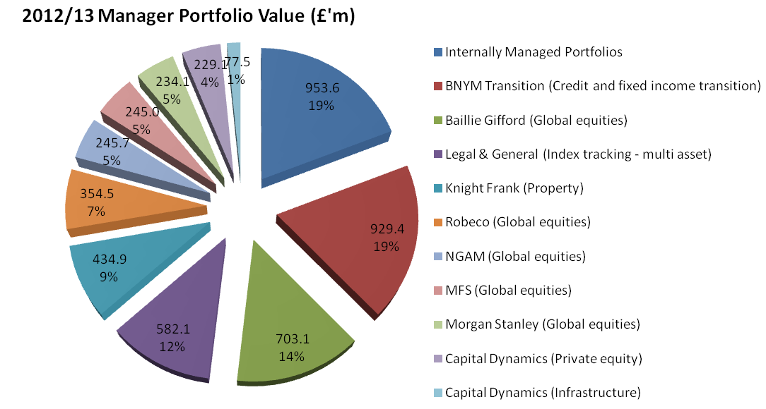

During 2012/13 the implementation of the revised investment strategy, agreed in 2010, continued. The Fund successfully completed the transition to the new global equities investment Managers with effect from 1 October 2012. The three existing equity mandates with JP Morgan (UK equities), Newton (Overseas equities) and BNY Mellon (Balanced tracking equity mandate) were sold and replaced by mandates with 5 managers each with an unconstrained global equity mandate (Baillie Gifford, MFS, Morgan Stanley, Robeco and NGAM) totalling £1.5 bn.
The transition of credit and fixed income assets has been undertaken by the appointed transition manager, Bank of New York Mellon. The resulting proceeds (£929m) are currently residing in a transition account in advance of future investment decisions being made into less commoditised and more specialist funds, including but not limited to secured lending, long-term lending, non-sterling lending, investment opportunities driven by changes to banking regulations, and index linked loans giving inflation protection.

Performance

The value of the Fund's assets has more than doubled over the last ten years, as shown in the chart below:

Total net asset value of the Fund over 10 years to date
2.449
2.783
3.478
3.689
3.670
2.934
3.962
4.294
4.380
5.011
0
1
2
3
4
5
2003/04
2004/05
2005/06
2006/07
2007/08
2008/09
2009/10
2010/11
2011/12
2012/13
£bn

The Fund is invested to meet liabilities over the medium to long-term and therefore its performance should be judged over a corresponding period. Annual returns can be volatile, as seen in 2008/09 and do not necessarily indicate the underlying health of the Fund.

The performance of the Fund is measured against a Fund specific benchmark with individual managers being given performance benchmarks and targets which are linked to index returns for the assets they manage. Details of these can be found in the Statement of Investment Principles Statement of Investment Principles. The Fund also subscribes to the annual WM Survey of UK Local Authority Pension Funds, which shows comparisons with other local authority pension funds. The performance of the investment managers is reviewed on a regular basis by the Panel and any recommendations arising from those reviews are considered by the Committee.

Looking first at total Fund returns, the chart below shows the total return of the Fund compared to the fund specific benchmark and the average local authority pension fund return measured over 1,3,5 and 10 years to 31 March 2013:

The Fund's return of almost 14.9% is above that of the average local authority pension fund of 13.8%. It ranks as the 24th percentile in the WM analysis of local authority funds.

In the year to 31 March 2013, The Total Fund return amounted to 14.9% against a benchmark of 13.5%. This significantly outperformed the Gilts +2.5% actuarial measure of 7.9% for the same period. A significant proportion of this performance was derived from global equities, delivering 20.9% in the year against a benchmark of 18.0%. Property and Bonds asset classes also exceeded their respective benchmarks, with non-investment grade assets being approximately on parity. Infrastructure assets, whose performance has been strong throughout the year, has now fallen back as the significant returns produced by the Red Rose infrastructure vehicle dropped out of the one year rolling performance.
Whilst all of the new equity managers have produced significant returns since the October 2012 inception of their mandates, Baillie Gifford, MFS, and NGAM have exceeded their benchmarks most notably with the other two managers, with being more defensive strategies, also close to benchmarks. Capital Dynamics produced a disappointing return of 3.5% for the year to 31 March 2013 against a benchmark of 16.8% but continues to provide strong long-term performance with returns of 9.9% since inception against a benchmark of 4.98%.
The Fund’s investment managers are set performance targets as shown in the Statement of Investment Principles Statement of Investment Principles. The overall performance target of each manager is measured over rolling three and five year periods, as inevitably there will be short-term fluctuations in performance. These targets are set for the active managers i.e. those with a mandate to outperform a benchmark through active stock picking and sector allocations. The transition portfolio and that managed by Legal and General are passive portfolios where the manager seeks to track the benchmark.

Active managers have the discretion to invest a smaller or greater amount than the benchmark allocation, within agreed constraints and tolerances. These decisions will reflect their views on market conditions within various countries or between different types of instruments. The one year performance of the managers and asset classes to 31 March 2013 are shown in the following charts:

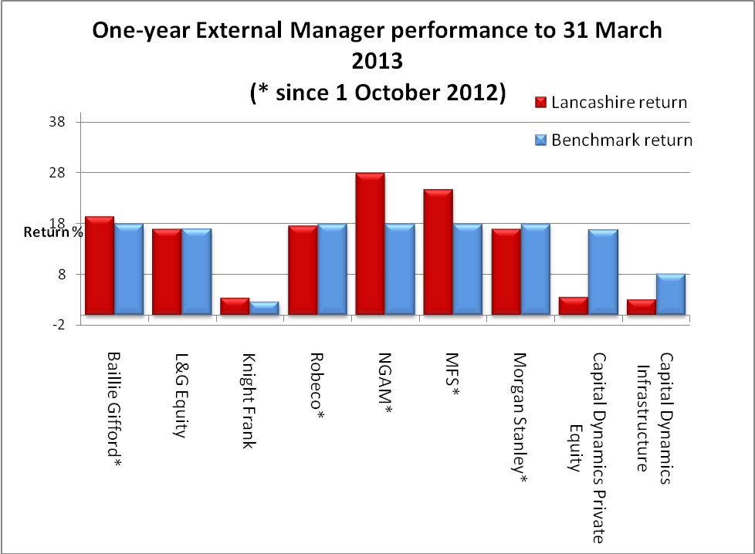

As part of an overall portfolio strategy Robeco and Morgan Stanley were hired as defensive managers. As expected in a strongly performing market they have underperformed their benchmark. NGAM and MFS were appointed with a growth bias and the significant out -performance against benchmark reflects this. It can be argued that the long term nature of Private Equity and Infrastructure allocations are such that one year measures are invalid, as investment during the initial stages (years 1-3) generates returns in the later stages (years4-7).

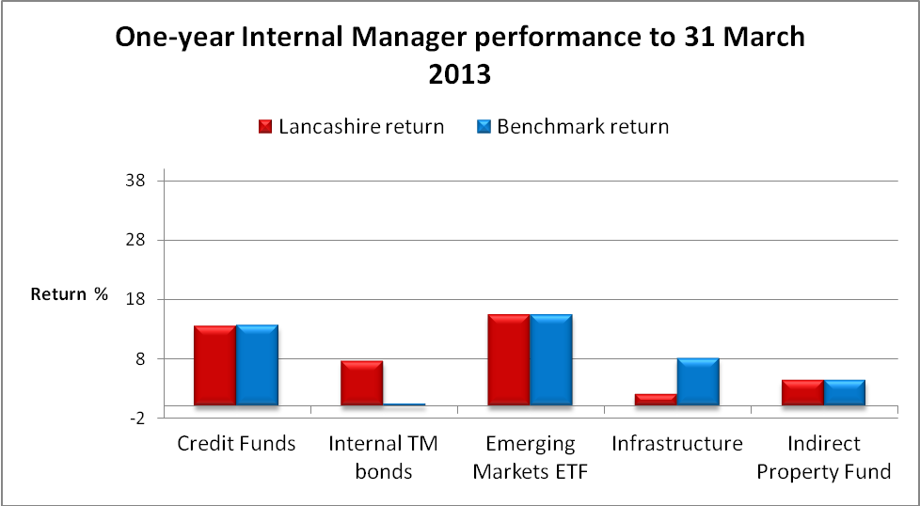

Emerging markets are passively managed and have therefore performed on a par with their benchmark. Whilst both credit funds and infrastructure are in the early stages of investment, credit funds are currently performing on a par with their benchmark whereas infrastructure as expected at a relatively early stage in the investment cycle is performing below benchmark.

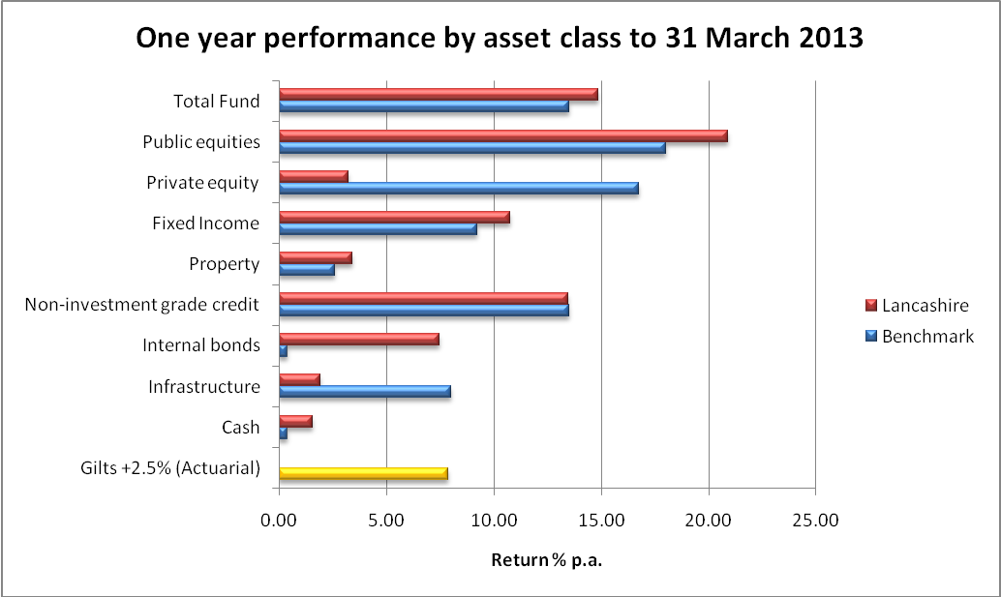

As a result of substantial asset allocation classes changes made in the period, the total fund performance is ahead of benchmark and ahead of actuarial assumptions.

An analysis of the specialist managers’ performance since inception is shown in the chart below:

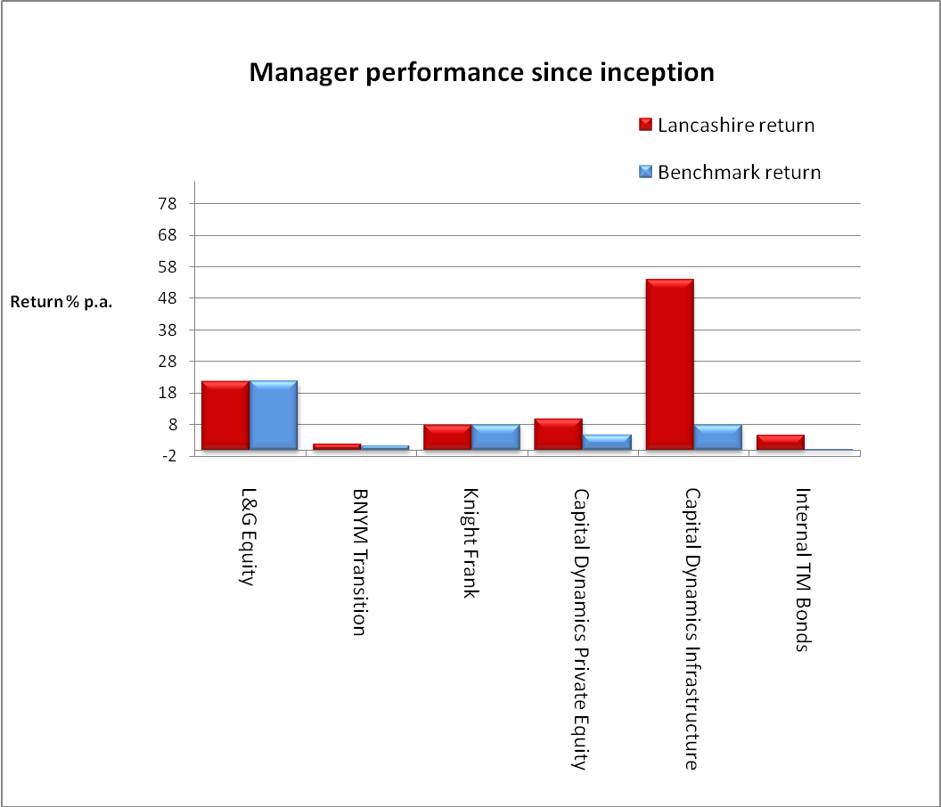

Since inception all managers have performed in line or in excess of their benchmark.

This move towards lower volatility asset classes has resulted in equities accounting for 58% of the Fund at 31 March 2013, compared with 77% three years ago. In the same period, lower volatility assets have increased from 16% to 33%. Against target allocations, equities however remain towards the top of their respective target (40%-60%), property remains just below the bottom of its target range (10%-20%), and lower volatility assets are mid-range (20%-40%).

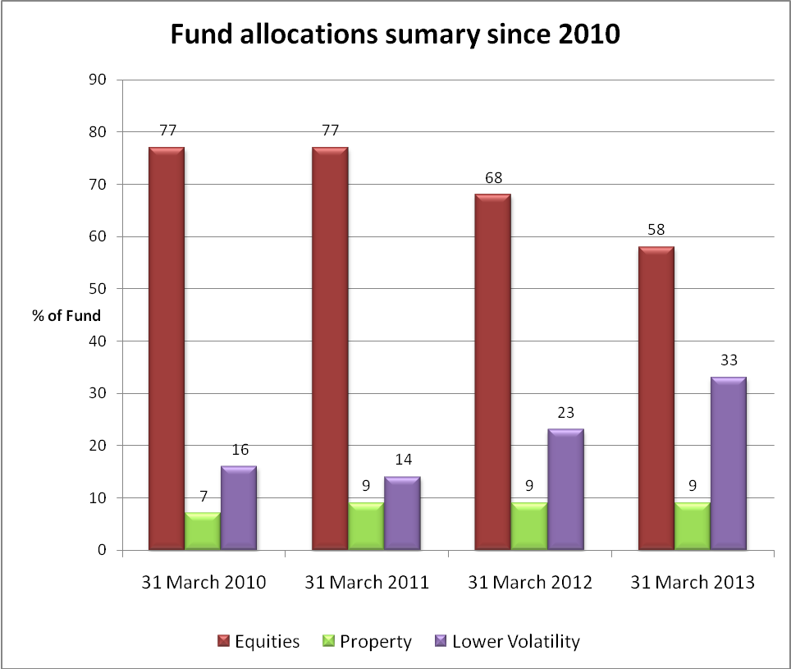

n/a

Asset allocations

The Fund is continuing to implement its revised investment strategy agreed in 2010, in actively bringing asset allocations up to the agreed benchmarks, in order to reduce the reliance on more volatile assets such as equities, in favour of less volatile asset classes such as infrastructure, senior secured loans, and emerging market debt funds.

Detailed asset class allocations, and a comparison with the previous year is shown below:

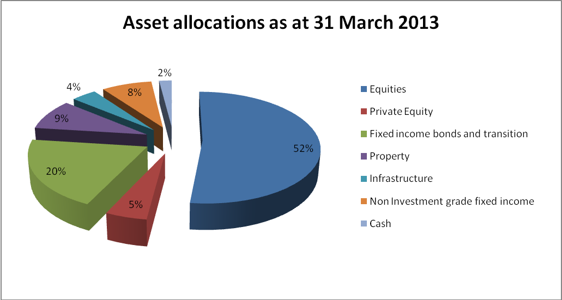

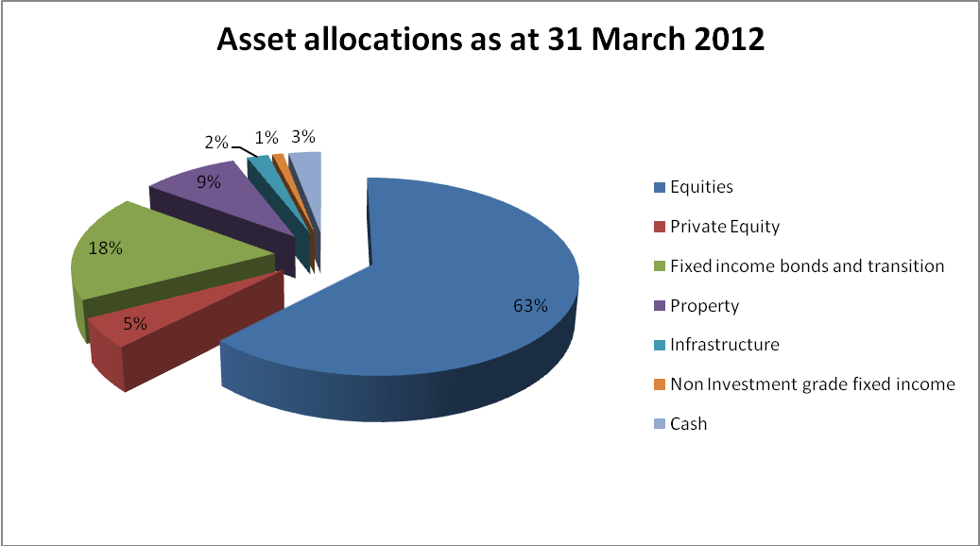

While paid up investments in infrastructure funds represent 4% of the value of the Fund, the Fund also has unpaid commitments to infrastructure funds equivalent to 3.8% of the value of the Fund at 31 March 2013.

Similarly, unpaid private equity commitments at 31 March 2013 are £137m, comprising 2.7% of The Fund in addition to the paid up investments representing 5.6% of the Fund.

The largest individual direct investments of the Fund are disclosed in the following paragraphs:

The Largest ten equity holdings of the Fund at 31 March 2013 were:

 | Equity | Market value  31 March 2013  £m | Percentage of net assets of the Fund %
 | Nestle SA CHF0.10 (Regd) | 54.5 | 1.09
 | British American Tobacco Ord GBP0.25 | 33.8 | 0.68
 | Reckitt Benck Grp Ord GBP0.10 | 29.0 | 0.58
 | Visa Inc Com CL A STK | 27.7 | 0.55
 | Omnicom Group Inc Com | 24.8 | 0.50
 | Diageo Ord Plc | 24.4 | 0.49
 | Accenture Plc SHA CL A New | 23.4 | 0.47
 | CIE Financie Richemont CHF | 22.2 | 0.45
 | Philip Morris Intl Com Stk NPV | 22.0 | 0.44
 | Mastercard Inc CL A | 21.9 | 0.44
 | Total | 283.7 | 5.69%

The largest ten direct property holdings of the Fund at 31 March 2013 were:

 | Property | Sector | Market value  31 March 2013  £m
 | 10 Brook St, London | Offices | 34.5
 | Sainsburys Store, Elgiva Lane, Chesham | Shops | 29.2
 | Princes Mead Shopping Centre, Farnborough | Shopping Centre | 23.8
 | St Edmundsbury Retail Park, Bury St Edmunds | Retail Warehouse | 18.7
 | Benson House, Leeds | Offices | 17.2
 | Somerfield Store, Wymondham | Shops | 15.3
 | 1-3 Dufferin St, London | Offices | 14.6
 | Stukeley Road Retail Park, Huntingdon | Retail Warehouse | 14.5
 | Weir Road, Wimbledon | Industrial / Warehouse | 14.4
 | Tuscany Park, Wakefield | Industrial / Warehouse | 14.1
 | Total |  | 196.3

Policies in respect of Socially Responsible Investment and Voting

Social, Environmental and Ethical Considerations

The Fund is active on governance issues through its membership of the Local Authority Pension Fund Forum ("LAPFF"), which exists to promote the investment interests of local authority pension funds, and to maximise their influence as shareholders whilst promoting social responsibility and corporate governance at the companies in which they invest.

The Fund also uses the services of Pensions Investment Research Consultants ("PIRC"), which is a leading independent research and advisory consultancy providing services to institutional investors on corporate governance and corporate social responsibility.

Policy on Voting

For many years, the Fund has followed the voting recommendations of PIRC with the Fund's managers being instructed to vote at shareholder meetings in accordance with PIRC's recommendations. PIRC has been acting as the Fund's proxy since 2011 and casting the Fund's votes directly at shareholder meetings.

The Fund's investment managers receive advance notice of PIRC's voting intentions and may raise concerns with the Fund if they do not believe the recommended stance on a vote is in the best financial interests of the Fund.

The Committee delegates its agreement of any significant departure from the guidelines proposed by the managers, to the Treasurer as Chair of the Investment Panel. In all voting decisions the long-term financial interests of the Fund are paramount. There were no occurrences of this during 2012/13.

Policy on Risk

The overriding objective of the Fund in respect of its investments is to strike a balance between minimising risk and maximising return. The structure of the investment management arrangements has been implemented in order to produce a balanced spread of risk for the portfolio. Within this the managers are regularly challenged by the Panel about the risk profile of the portfolios that they manage for the Fund.

Compliance with Myners Principles

The Fund is compliant with the Myners Principles, details of which can be found in the Statement of Investment Principles. Statement of Investment Principles

- Accounts of the Fund

Responsibilities for the Statement of Accounts

The Responsibilities of the Administering Authority

The Administering Authority is required:

- To make arrangements for the proper administration of the financial affairs of the Lancashire County Pension Fund (Pension Fund), and to ensure that an officer has the responsibility for the administration of those affairs. For Lancashire County Council, the respective officer is the County Treasurer, who is also the Treasurer to the Pension Fund;

- To manage its affairs to secure economic, efficient and effective use of resources, and to safeguard its assets.

The Responsibilities of the Treasurer to the Pension Fund

The Treasurer to the Pension Fund is responsible for the preparation of the Pension Fund’s statement of accounts. In accordance with the CIPFA Code of Practice on Local Authority Accounting in Great Britain (the Code), the statement is required to present fairly the financial position of the Pension Fund at the accounting date, and its income and expenditure for the year then ended.

In preparing this statement of accounts, the Treasurer to the Pension Fund has:

- Selected suitable accounting policies and then applied them consistently;
- Made judgements and estimates that were reasonable and prudent;
- Complied with the Code.

In addition, the Treasurer to the Pension Fund has:

- Kept proper accounting records which were up to date;

- Taken responsible steps for the prevention and detection of fraud and other irregularities.

The Statement of Accounts relate to the financial year ended 31 March 2013 and include the Fund Account and the Statement of Net Assets which are prepared in accordance with standard accounting practice as outlined in the notes to the accounts of the Pension Fund.

Gill Kilpatrick CPFA
Treasurer to the Lancashire County Pension Fund
30 September 2013

INDEPENDENT AUDITOR’S REPORT TO THE MEMBERS OF LANCASHIRE COUNTY COUNCIL

Opinion on the pension fund financial statements
We have audited the pension fund financial statements of Lancashire County Pension Fund for the year ended 31 March 2013 under the Audit Commission Act 1998. The pension fund financial statements comprise the Fund Account, the Net Assets Statement and the related notes. The financial reporting framework that has been applied in their preparation is applicable law and the CIPFA/LASAAC Code of Practice on Local Authority Accounting in the United Kingdom 2012/13.
This report is made solely to the members of Lancashire County Pension Fund in accordance with Part II of the Audit Commission Act 1998 and for no other purpose, as set out in paragraph 48 of the Statement of Responsibilities of Auditors and of Audited Bodies published by the Audit Commission in March 2010. To the fullest extent permitted by law, we do not accept or assume responsibility to anyone other than the Authority and the Authority's Members as a body, for our audit work, for this report, or for the opinions we have formed.

Respective responsibilities of the Treasurer to the Pension Fund and auditor

As explained more fully in the Statement of the Responsibilities of the Treasurer to the Pension Fund, the Treasurer to the Pension Fund is responsible for the preparation of the pension fund’s financial statements and for being satisfied that they give a true and fair view. Our responsibility is to audit and express an opinion on the financial statements in accordance with applicable law and International Standards on Auditing (UK and Ireland). Those standards require us to comply with the Auditing Practices Board’s Ethical Standards for Auditors.

Scope of the audit of the pension fund financial statements

An audit involves obtaining evidence about the amounts and disclosures in the financial statements sufficient to give reasonable assurance that the financial statements are free from material misstatement, whether caused by fraud or error. This includes an assessment of: whether the accounting policies are appropriate to the fund’s circumstances and have been consistently applied and adequately disclosed; the reasonableness of significant accounting estimates made by the Treasurer to the Pension Fund; and the overall presentation of the financial statements. In addition, we read all the financial and non-financial information in the annual report to identify material inconsistencies with the audited financial statements. If we become aware of any apparent material misstatements or inconsistencies we consider the implications for our report.

Opinion on other matters

In our opinion, the information given in the pension fund annual report for the financial year for which the financial statements are prepared is consistent with the financial statements.

Matters on which we report by exception

We report to you if, in our opinion the governance compliance statement does not reflect compliance with the Local Government Pension Scheme (Administration) Regulations 2008 and related guidance. We have nothing to report in this respect.

In our opinion the pension fund’s financial statements:
- give a true and fair view of the financial transactions of the pension fund during the year ended 31 March 2013 and the amount and disposition of the fund’s assets and liabilities as at 31 March 2013 and
- have been properly prepared in accordance with the CIPFA/LASAAC Code of Practice on Local Authority Accounting in the United Kingdom 2012/13.

Karen Murray
Director
for and on behalf of Grant Thornton UK LLP, Appointed Auditor
4 Hardman Square
Spinningfields
Manchester
M3 3EB

30 September 2013

Fund Account

 |  |  | Note |  |  | 2012/13  £m |  |  |  |  |  | *2011/12  £m
Dealing with members, employers and others directly involved in the fund
Contributions |  | 6 |  |  | 202.7 |  |  |  |  |  | 209.3
Transfers in |  | 7 |  |  | 9.9 |  |  |  |  |  | 11.1
 |  |  |  |  | 212.6 |  |  |  |  |  | 220.4
Benefits |  | 8 |  |  | (210.2) |  |  |  |  |  | (219.1)
Payments to and on account of leavers  Administrative expenses |  | 9  10 |  |  | (12.6)  (5.0) |  |  |  |  |  | (13.7)  (3.8)
 |  |  |  |  | (227.8) |  |  |  |  |  | (236.6)
Net withdrawals from dealings with members |  |  |  |  | (15.2) |  |  |  |  |  | (16.2)

Return on investments
Investment income | 11 | 120.8 |  | 117.6
Profit and loss on disposal of investments and change in market value of investments | 14 | 532.6 |  | (7.9)
Investment management expenses | 20 | (7.2) |  | (7.1)
Net return on investments |  | 646.2 |  | 102.6
Net increase (decrease) in the net assets available for benefits during the year |  | 631.0 |  | 86.4

*Prior year has been restated to reflect net rental income from properties in investment income.

Net Asset statement for the year ended 31 March 2013

 | Note | 2013  £m |  | 2012  £m
Investment assets | 14 | 4,990.9 |  | 4,361.4
Investment liabilities | 14 | (1.9) |  | (1.5)
Current assets | 21 | 31.7 |  | 23.3
Current liabilities | 23 | (9.7) |  | (3.2)
Net assets of the fund available to fund benefits at the period end |  | 5,011.0 |  | 4,380.0

The Pension Fund's financial statements do not take account of liabilities to pay pensions and other benefits after the period end.

This statement of accounts is that upon which the auditor should enter his certificate and opinion. It presents fairly the position of the Lancashire County Pension Fund at 31 March 2013 and its income and expenditure for the year then ended.

Gill Kilpatrick CPFA | Cllr Clare Pritchard
Treasurer to the Lancashire  County Pension Fund | Chair of the Audit Committee

Notes to the Financial Statements

- Pension Fund Operations and Membership
The Lancashire County Pension Fund is part of the Local Government Pension Scheme and is administered by Lancashire County Council. The county council is the reporting entity for this pension fund.

The published accounts show that in 2012/13 cash inflows during the year consisted of £333.4 million and cash outflows were £235 million, representing a net cash inflow of £98.4 million (compared with an inflow of £94.3 million in the previous year). Benefits payable amounted to £210.2 million and were partially offset by net investment income of £120.8 million (including £21.6 million accrued dividends); contributions of £202.7 million and transfers in of £9.9 million produced the positive cash inflow.

The increase in net gain resulted from the fund executing a switch from a domestic equities strategy to a global strategy in October 2012. Since that date, the US Dollar has appreciated significantly against the Pound. This, along with long term interest rates which fell slightly whilst credit spreads tightened significantly, lead to an increase in the capital values of fixed-rate securities as the discount rates used to value them fell, contributing to an additional increase in market value

- General

The fund is governed by the Superannuation Act 1972. The fund is administered in accordance with the following secondary legislation:

- the LGPS (Benefits, Membership and Contributions) Regulations 2007 (as amended)
- the LGPS (Administration) Regulations 2008 (as amended)
- the LGPS (Management and Investment of Funds) Regulations 2009

It is a contributory defined benefit pension scheme administered by Lancashire County Council to provide pensions and other benefits for pensionable employees of Lancashire County Council, the district councils in Lancashire County and a range of other scheduled and admitted bodies within the county area. Teachers, police officers and firefighters are not included as they come within other national pension schemes.

The investments of the Pension Fund are managed by nine external investment managers. The asset allocation and policy in respect of the investments of the Fund is determined by the Pension Fund Committee, which meets four times a year with the Investment Panel in attendance. The Investment Panel meet at least quarterly, or otherwise as necessary. The panel are responsible for making recommendations to the Pension Fund Committee in relation to the investment strategy of the fund as well as monitoring the activities and performance of the investment managers. Full details of the Panel and Committees responsibilities are published in the Funds Statement of Investment Principles and are available from the Funds website at http://www.yourpensionservice.org.uk

- Membership

Membership of the LGPS is voluntary and employees are free to choose whether to join the scheme, remain in the scheme or make their own personal arrangements outside the scheme.

Organisations participating in the Lancashire County Pension Fund include:

- Scheduled bodies, which are local authorities and similar bodies whose staff are automatically entitled to be members of the fund.
- Admitted bodies, which are other organisations that participate in the fund under an admission agreement between the fund and the relevant organisation. Admitted bodies include voluntary, charitable and similar bodies or private contractors undertaking a local authority function following outsourcing to the private sector.

Participation in the Pension Fund

 | Number at  31 March 2013 | Number at  31 March 2012
- Active Scheme Members  Scheduled Bodies | 49,391  3,572 | 46,422  3,716
Admitted Bodies | 49,391  3,572 | 46,422  3,716
Total | 52,963 | 50,138
- Pensioners  Pensions in Payment | 40,885  49,837 | 39,933  47,526
Preserved Pensions | 40,885  49,837 | 39,933  47,526
Total | 90,722 | 87,459

- Funding

Benefits are funded by contributions and investment earnings. Contributions are made by active members of the fund in accordance with the LGPS (Benefits, Membership and Contributions) Regulations 2007 and range from 5.5% to 7.5% of pensionable pay for the financial year ending 31 March 2013. Employee contributions are matched by employers' contributions which are set based on triennial actuarial funding valuations. The last such valuation was at 31 March 2010. Currently employer contributions range from 8.6% to 70.3% of pensionable pay.

- Benefits

Pension benefits under the LGPS are based on final pensionable pay and length of pensionable service in the following summary:

 | Service Pre 1 April 2008 | Service post 31 March 2008
Pension | Each year worked is worth 1/80 x final pensionable salary | Each year worked is worth 1/60 x final pensionable salary
Lump sum | Automatic lump sum of 3 x salary.  In addition, part of the annual pension can be exchanged for a one-off tax free cash payment. A lump sum of £12 is paid for each £1 of pension given up | No automatic lump sum.  Part of the annual pension can be exchanged for a one-off tax free cash payment. A lump sum of £12 is paid for each £1 of pension given up

There are a range of other benefits provided under the scheme including early retirement, disability pensions and death benefits.

Benefits are index-linked in order to keep pace with inflation. In June 2010, the government announced that the method of indexation would change from the retail price index to the consumer price index. This change took effect from 1 April 2011.

LGPS 2014

A Statutory Consultation started on 21 December 2012 on new benefit regulations for the Local Government Pension Scheme (LGPS) from 1 April 2014. A number of further consultations have followed with the intention of having a new LGPS in place by 1 April 2014. This new Scheme will reflect the provisions of the Public Service Pensions Bill which having worked its way through Parliament reached Royal Assent on 25 April 2013.
The main provisions of the new LGPS 2014 are:

• The Scheme will be a Career Average Re-valued Earnings (CARE) Scheme with an accrual rate of 1/49th.
• The Scheme will be re-valued in line with Consumer Price Index (CPI).
• Pay will include non-contractual overtime and for part time staff pay will include additional hours.
• Flexibility in contributions will mean an optional arrangement allowing 50% of main benefits to be accrued by paying a 50% contribution rate.
• Normal Pension age will be the same as the individual member’s State Pension Age (minimum 65).

The next step of the ongoing statutory consultation process is to ensure that the regulations covering the protections for current scheme members (known as the
transitional regulations) are in place. These regulations describe how the move from current to new rules take place and set the foundations for protections. In particular protections will include a final salary link and protected retirement age for benefits built up to March 2014.
Over the forthcoming year the Fund will be putting together a comprehensive communications plan in order to keep scheme members informed of these changes.

- Basis of Preparation

The Statement of Accounts summarises the fund's transactions for the 2012/13 financial year and its position at year-end as at 31 March 2013. The accounts have been prepared in accordance with the Code of Practice on Local Authority Accounting in United Kingdom 2012/13 which is based on International Financial Reporting Standards (IFRS), as amended for the UK public sector.

The accounts summarise the transactions of the fund and report the net assets available to pay pension benefits. They do not take account of obligations to pay pensions and benefits which fall due after the end of the financial year. The actuarial present value of promised retirement benefits, value on an International Accounting Standard (IAS) 19 basis, is disclosed in note 30 of these accounts.

- Accounting Policies

Fund Account revenue recognition

- Contribution income

Normal contributions both from members and from the employer are accounted for on an accruals basis at the percentage rate recommended by the fund actuary in the payroll period to which they relate.

Employers' augmentation contributions and pension strain contributions are accounted for in the period in which the liability arises. Any amount due in the year but unpaid will be classed as a current financial asset. Amounts not due until future years are classed as long term financial assets.

- Transfers

Transfer values represent amounts received and paid during the period for individual members who have either joined or left the fund during the financial year and are calculated in accordance with Local Governance Pension Scheme Regulations.

Individual transfers in/out are accounted for when received/paid, which is normally when the member liability is accepted or discharged.

Transfers in from members wishing to use the proceeds of their additional voluntary contributions to purchase scheme benefits are accounted for on a receipts basis and are included in transfers in. Bulk (group) transfers are accounted for on an accruals basis in accordance with the terms of the transfer agreement.

- Investment Income

- Interest income

Interest income is recognised in the fund account as it accrues, using the effective interest rate of the financial instrument as at the date of acquisition or origination. Income

includes the amortisation of any discount or premium, transaction costs or other differences between the initial carrying amount of the instrument and its amount at maturity calculated on an effective interest rate basis.

- Dividend income

Dividend income is recognised on the date the shares are quoted ex-dividend. Any amount not received by the end of the reporting period is disclosed in the net asset statement as a current financial asset.

- Distribution from pooled funds

Distributions from pooled funds are recognised at the date of issue. Any amount not received by the end of the reporting period is disclosed in the net asset statement as a current financial asset.

- Rental income

Net rental income from operating leases on properties owned by the fund is recognised on a straight line basis over the term of the lease. Any lease incentives granted are recognised as an integral part of the total rental income, over the term of the lease. Contingent rents are only recognised when contractually due.

- Movement in the net market value of investments

Changes in the net market value of investments (including investment properties) are recognised as income and comprise all realised and unrealised profits/losses during the year.

Fund Account –expense items

- Benefits payable

Pensions and lump sum benefits payable included all amounts known to be due as at the end of the financial year. Any amounts due but unpaid are disclosed on the net asset statement as current liabilities.

- Taxation

The fund is a registered public service scheme under section 1(1) of Schedule 36 of the Finance Act 2004 and as such is exempt from UK income tax on interest received and from capital gains tax on the proceeds of investments sold. Income from overseas investments suffers withholding tax in the country of origin, unless exemption is permitted. Irrecoverable tax is accounted for as a fund expense as it arises.

- Administrative expenses

All administrative expenses are accounted for on an accruals basis. All other costs of administration are borne by the employer. The administration and processing expenses

are a proportion of relevant officers' salaries in respect of the time allocated to pension administration and investment issues.

- Investment Manager expenses

Investment management expenses are accounted for on an accruals basis. They include the fees paid and due to the fund managers, custodian, actuarial fees and performance measurement and investment consultant fees.

Fees of the external investment managers and custodian are agreed in the respective mandates governing their appointments. Broadly, these are based on the market value of investments under their management and therefore increase or reduce as the value of these investments change.

In addition the fund has negotiated with the following managers that an element of their fee be performance related:

- MFS
- Morgan Stanley

As yet no performance related fees have been paid to these managers due to them having only been appointed in October 2012.

Where an investment manager's fee note has not been received by the net asset statement date, an estimate based on market value of their mandate as at year end is used for the inclusion in the fund account. In 2012/13 £2.2m of fees is based on such estimates (2011/12 £1.3m).

The costs of the council's in-house fund management team are charged direct to the fund and a proportion of the council's costs representing management time spent by officers on investment management are also charged to the fund.

Net asset statement

- Financial Instruments

Financial assets are included in the net asset statement on a fair value basis other than loans and receivables as at the reporting date. A financial asset is recognised in the net asset statement on the date the fund becomes party to the contractual acquisition of the asset. From this date any gains or losses arising from changes in the fair value of the asset are recognised by the fund.
The assets and liabilities held by Lancashire County Pension Fund are classified as fair value through profit and loss, loans and receivables and liabilities at amortised cost.

Loans and receivables

Loans and receivables are non derivative financial assets with fixed or determinable payments that are not quoted in an active market.

The fund's loans and receivables comprise of trade and other receivables and cash deposits.

Financial liabilities at amortised cost

Financial liabilities at amortised cost are the default category for financial instruments that do not meet the definition of financial liabilities at fair value through profit and loss.

- Valuation of Investments

Investments are shown at their fair value as at 31 March 2013. The fair value is the current bid price for quoted securities and unitised securities.

Transaction costs are included in carrying value of investments. Transaction costs include costs charged directly to the Pension Fund, such as fees, commissions paid to agents, brokers and dealers, levies by regulatory agencies and securities exchanges and transfer taxes and duties.

Investments in Private Equity are valued at fair value in accordance with the guidelines issued by the British Venture Capital Association, or equivalent.

The methodologies adopted in valuing financial instruments are explained in greater detail in note 17.

- Currency Translation

Assets and liabilities denominated in foreign currency are stated in the accounts by the application of the appropriate closing rate of exchange ruling at 31 March 2013. Any gains or losses are treated as part of a change in market value of investments.

- Acquisition costs of Investments

The Acquisition costs of investments are included within the purchase price.

- Property

The fund's freehold and leasehold properties were valued on 31 March 2013 by Cushman & Wakefield, acting as External Valuer. The valuations were in accordance with the requirements of the RICS Valuation standards and the International Valuation Standards. The valuation of each property was on the basis of Market Value, assuming that the property would be sold subject to any existing leases. The valuer's opinion of Market Value and Existing Use Value was primarily derived using comparable recent market transactions on arm's length terms.

- Derivatives

The fund uses derivative financial instruments to manage its exposure to specific risks arising from its investment activities. The fund does not hold derivatives for speculative purposes.

Derivative contract assets are fair valued at bid prices and liabilities are fair valued at offer prices. Changes in fair value of derivative contracts are included in change in market value.

Future contracts are exchange traded and fair value is determined using exchange prices at their reporting date. Amounts due or owed to the broker are amounts outstanding in respect of initial margin and variation margin.

Forward foreign exchange contracts, are over the counter contracts and are valued by determining the gain or loss that arise from closing out the contract at the reporting date, by entering into an equal and opposite contract at that date.

- Cash and cash equivalents

Cash comprises of cash in hand and demand deposits.

Cash equivalents are short-term, highly liquid investments that are readily convertible to known amounts of cash and that are subject to minimal risk of changes in value.

- Financial liabilities

The fund recognises financial liabilities at fair value other than loans and receivables at the reporting date. A financial liability is recognised in the net asset statement on the date the fund becomes party to a liability. From this date any gains or losses arising from changes in the fair value of the liability are recognised by the fund.

- Actuarial present value of promised retirement benefits

The actuarial present value of promised retirement benefits is assessed on a triennial basis by the scheme actuary in accordance with the requirements of IAS19 and relevant actuarial standards.

As permitted under IAS 26 the fund has opted to disclose the actuarial present value of promised retirement benefits by way of a note to the net asset statement (Note 30).

- Additional voluntary contributions

The AVC providers to the Pension Fund are Equitable Life and Prudential. The AVC’s are invested separately from the Pension Fund’s main assets and used to acquire additional money purchase benefits. These are not included in the Pension Fund accounts in accordance with section 4(2)(b) of the Local Government Pension Scheme (Management and Investment of Funds) Regulations 2009 (SI 2009/3093). Members participating in these AVC arrangements each receive an annual statement confirming the amounts held in their account and the movements during the year. A summary of the information provided by Equitable Life and Prudential is shown in note 19.

- Securities Lending

Investments lent under securities lending arrangements continue to be recognised in the net asset statement to reflect the scheme's continuing economic interest in the securities and are measured in accordance with the accounting policy for assets 'At fair value through income statement' or 'Available for sale' as appropriate.
Collateral is marked to market, and adjusted daily. As the Fund has an obligation to return the collateral to the borrowers, collateral is excluded from the Fund valuation.

- Contingent liabilities and contingent assets
A contingent liability is a possible obligation that arises from past events whose existence will be confirmed by the occurrence or non-occurrence of one or more uncertain future events beyond the control of the Fund or a present obligation that is not recognised because it is not probable that an outflow of resources will be required to settle the obligation. A contingent liability also arises in extremely rare cases where there is a liability that cannot be recognised because it cannot be measured reliably. The Fund does not recognise a contingent liability but discloses its existence in the financial statements.
A contingent asset is a possible asset that arises from past events whose existence will be confirmed by the occurrence or non-occurrence of one or more uncertain future events beyond the control of the Fund. The Fund does not recognise contingent assets but discloses its existence where inflows of economic benefits are probable, but not virtually certain.

- Critical Judgements in applying accounting policies

The fund has recognised a deposit with Landsbanki as an asset on the net asset statement as at 31st March 2013. Judgement is required in determining the recoverability of this asset at each net asset statement date. The Fund has assessed recoverability with reference to Landsbanki's financial position as at 31st December 2012 as published by the bank's Winding Up Board and considers that it is likely that 100% of the deposit, subject to exchange rate fluctuations, will be recovered. This is in line with advice issued by CIPFA and LAPFF.

- Assumptions made about the future and other major sources of estimated uncertainty

The Statement of Accounts contains estimated figures that are based on assumptions made by the Pension Fund about the future or that are otherwise uncertain. Estimates are made taking into account historical experience, current trends and other relevant factors. However, because balances cannot be determined with certainty, actual results could be materially different from the assumptions and estimates.

The items in the Pension Fund's net asset statement at 31 March 2013 for which there is a significant risk of material adjustment in the forthcoming year are as follows:

Item | Uncertainties | Impact if actual results differ from assumptions
Private Equity, Infrastructure,  Local Authority Bonds and Indirect Overseas Property | Private Equity and Infrastructure investments are valued at fair value in accordance with British Private Equity and Venture Capital Association guidelines / International Private Equity and Venture Capital Valuation guidelines or equivalent. Local authority bonds are based on valuation techniques that require management judgements based on various factors. Overseas indirect properties are valued at the current open market value as defined by the RICS Appraisal and Valuation Standards. These investments are not publicly listed and as such there is a degree of estimation involved in the valuation. | Private equity, infrastructure, local authority bonds and overseas indirect property investments in the financial statements total £408.5m. There is a risk that these investments may be under or overstated in the accounts.
Pensions Liability |  | The effects on the net pension liability of changes in individual assumptions can be measured. For instance, a 0.5% increase in the discount rate assumption would reduce the value of the liabilities by approximately £624 million. A 0.25% increase in assumed earnings inflation would increase the value of the liabilities by approximately £86m and a 1 year increase in assumed life expectancy would increase the liabilities by approximately £146m.
  Estimation of the net liability to pay pensions depends on a number of complex judgements relating to the discount rate used, the rate at which salaries are projected to increase, changes in retirement ages, mortality rates and expected returns on pension fund assets. A firm of consulting actuaries (Mercers) is engaged to provide the authority with expert advice about the assumptions to be applied.

- Contributions receivable
 | 2012/13  £m |  | 2011/12  £m
Employers' contributions
County Council | 63.4 |  | 68.5
Scheduled Bodies | 74.7 |  | 75.7
Admitted | 12.9 |  | 12.9
 | 151.0 |  | 157.1
Employees' contributions
County Council | 20.6 |  | 20.5
Scheduled Bodies | 26.3 |  | 26.8
Admitted | 4.8 |  | 4.9
 | 51.7 |  | 52.2
Total contributions | 202.7 |  | 209.3

Within the employee contributions figure for 2012/13, £0.2m is voluntary and additional regular contributions. All employer contributions are normal contributions.

- Transfers in
 | 2012/13  £m |  | 2011/12  £m
Individual transfers in from other schemes | 9.9 |  | 11.1
 | 9.9 |  | 11.1

- Benefits
 |  | 2012/13  £m |  | 2011/12  £m
Pensions |  | 176.5 |  | 163.6
Lump sum retirement benefits |  | 28.3 |  | 51.0
Lump Sum death benefits |  | 5.4 |  | 4.5
 |  | 210.2 |  | 219.1
Relating to:
County Council | 91.4 |  | 91.9
Scheduled Bodies | 105.7 |  | 112.6
Admitted Bodies | 13.1 |  | 14.6
Total | 210.2 |  | 219.1

- Payments to and on account of leavers
 | 2012/13  £m |  | 2011/12  £m
Refunds to members leaving service | 0 |  | 0.1
Contributions equivalent premium | 0 |  | (0.1)
Individual transfers to other schemes | 12.6 |  | 13.7
 | 12.6 |  | 13.7

- Administrative expenses
 | 2012/13  £m |  | 2011/12  £m
Administration and processing | 3.8 |  | 3.4
Audit fee | 0.1 |  | 0.1
Legal and other professional fees | 1.1 |  | 0.3
 | 5.0 |  | 3.8

- Investment income
 | 2012/13  £m |  | *2011/12  £m
Fixed interest securities | 21.5 |  | 27.7
Equity dividends | 59.5 |  | 46.5
Index linked securities | 1.2 |  | 2.8
Pooled investment vehicles | 6.3 |  | 5.5
Net rents from properties | 25.0 |  | 24.8
Interest on cash deposits | 2.8 |  | 0.7
Other | 4.5 |  | 9.6
 | 120.8 |  | 117.6
*Prior year has been restated to reflect net rental income from properties in investment income.

- Net rents from Properties
 | 2012/13  £m |  | 2011/12  £m
Rental Income | 28.1 |  | 26.0
Direct operating expenses | (3.1) |  | (1.2)
Net income | 25.0 |  | 24.8

- Stock Lending
Northern Trust the Fund's custodian, are authorised to release stock to a third party under stock lending arrangements up to the statutory limits for this activity. Stock lending income generated in 2012/13 was £643,034 (2011/12 £467,745)
Securities on loan at the 31st March 2013 were £107.9m and are included in the net asset statement to reflect the scheme's continuing economic interest in the securities. This consisted of £91.9m of equities and £16m of bonds.
Collateral is marked to market, and adjusted daily. Additional collateral of between 2% and 5% is requested as an additional measure of industry standard practice to mitigate risk. As the Fund has an obligation to return the collateral to the borrowers, collateral is excluded from the Fund valuation. The collateral is non cash and totalled £116.6m of government bonds.

- Reconciliation of movements in investments and derivatives
 | Market Value at 1 April 2012 |  |  |  |  | Purchases at cost and derivative payments |  |  |  | Sales proceeds and derivative receipts |  |  |  | Change in market  value |  |  | Market value at 31 March  2013
 |  | £m |  |  |  |  |  | £m |  |  | £m |  | £m |  |  |  | £m
Fixed interest securities |  | 623.4 |  |  |  |  | 501.1 |  | (471.9) |  |  |  |  |  | 191.0 |  |  | 843.6
Equities |  | 1,613.7 |  |  |  |  | 1,409.8 |  | (1,581.2) |  |  |  |  |  | 307.0 |  | 1,749.3
Index linked securities |  | 124.6 |  |  |  |  | 16.1 |  | (29.1) |  |  |  |  |  | 53.3 |  |  | 164.9
Pooled investments |  | 1,466.3 |  |  |  |  | 696.6 |  | (558.9) |  |  |  |  |  | (2.8) |  | 1,601.2
Property |  | 383.9 |  |  |  |  | 72.1 |  | (5.3) |  |  |  |  |  | (15.8) |  |  | 434.9
 |  | 4,211.9 |  |  |  |  |  | 2,695.7 | (2,646.4) |  |  |  |  |  | 532.7 |  | 4,793.9
Derivative contracts:  Futures |  | 0.2 |  |  |  | 0.4 |  |  | (0.5) |  |  |  |  |  |  | (0.1) |  | 0.0
Forward currency contracts |  | 1.6 |  |  |  |  |  |  |  |  |  |  |  |  |  |  |  | 3.0
Cash deposits |  | 126.8 |  |  |  |  |  |  |  |  |  |  |  |  |  |  |  | 170.5
Investment accruals |  | 19.4 |  |  |  |  |  |  |  |  |  |  |  |  |  |  |  | 21.6
 |  |  | 4,359.9 |  |  |  |  |  |  |  |  |  |  |  |  |  | 4,989.0

 | Market Value at 1 April  2011 |  |  | Purchases at cost and derivative payments |  |  |  | Sales proceeds and derivative receipts |  | Change in market value | Market value at 31 March 2012
 |  | £m |  |  |  | £m |  |  | £m | £m |  | £m
Fixed interest securities |  | 559.1 |  |  |  | 696.0 |  |  | (657.8) | 26.1 |  | 623.4
Equities |  | 1,735.1 |  |  |  | 401.0 |  |  | (441.9) | (80.5) |  | 1,613.7
Index linked securities |  | 141.0 |  |  |  | 120.9 |  |  | (159.1) | 21.8 |  | 124.6
Pooled investments |  | 1,395.5 |  |  |  | 399.2 |  |  | (359.6) | 31.2 |  | 1,466.3
Property |  | 397.5 |  |  |  | 24.2 |  |  | (34.1) | (3.7) |  | 383.9
 |  | 4,228.2 |  |  |  | 1,641.3 |  |  | (1,652.5) | (5.1) |  |  | 4,211.9
Derivative contracts:  Futures |  | 0.9 |  |  |  | 41.4 |  |  | (39.3) | (2.8) |  |  | 0.2
Forward currency contracts |  | 0.9 |  |  |  |  |  |  |  |  |  |  | 1.6
Cash deposits |  | 36.6 |  |  |  |  |  |  |  |  |  |  | 126.8
Investment accruals |  | 14.6 |  |  |  |  |  |  |  |  |  |  | 19.4
 |  | 4,281.2 |  |  |  |  |  |  |  |  |  |  | 4,359.9

Of the £532.7m increase in market value of investments during the 2012/13 financial year, £30.0m relates to assets for which fair value is not based on observable market data. The valuation policy for these assets is outlined in note 17.

Transaction costs are included in the cost of purchases and in sale proceeds. Transaction costs include costs charged directly to the Pension Fund, such as fees, commissions paid to agents, brokers and dealers, levies by regulatory agencies and securities exchanges and transfer taxes and duties. Transaction costs incurred during the year 2012/13 amounted to £2.2m (2011/12: £2.0m).
The investment assets at 31 March 2013 are managed by nine external investment managers, with the remaining cash deposits managed in-house. Details of the split of the investment assets by investment manager is shown below:

Summary of Manager's Portfolio Values as at 31st March 2013
 |  | 2012/13 |  |  | 2011/12
 |  | £m | % |  | £m | %
Externally Managed
BNYM Transition (Credit and fixed income transition) |  | 929.4 | 19% |  | - | 0%
Baillie Gifford (Global equities) |  | 703.1 | 14% |  | - | 0%
Legal & General (Index tracking - multi asset) |  | 582.1 | 12% |  | 1,057.4 | 24%
Knight Frank (Property) |  | 434.9 | 9% |  | 383.9 | 9%
Robeco (Global equities) |  | 354.5 | 7% |  | - | 0%
NGAM (Global equities) |  | 245.7 | 5% |  | - | 0%
MFS (Global equities) |  | 245.0 | 5% |  | - | 0%
Morgan Stanley (Global equities) |  | 234.1 | 5% |  | - | 0%
Capital Dynamics (Private equity) |  | 229.1 | 4% |  | 222.4 | 5%
Capital Dynamics (Infrastructure) |  | 77.5 | 1% |  | 50.4 | 1%
Newton (Global equities) |  | - | 0% |  | 615.6 | 14%
JP Morgan (UK equities) |  | - | 0% |  | 501.4 | 12%
BNYM Transition (Global equities) |  | - | 0% |  | 617.1 | 14%
UBS (Bonds) |  | - | 0% |  | 672.7 | 15%
Externally Managed Portfolios |  | 4,035.4 | 81% |  | 4,120.9 | 95%
Internally Managed
Credit Funds |  | 424.0 | 9% |  | 49.3 | 1%
Cash and bonds | Note 27 | 226.1 | 5% |  | 166.8 | 4%
Emerging markets ETF |  | 219.1 | 4% |  | - | 0%
Infrastructure Funds |  | 76.9 | 1% |  | 22.9 | 1%
Indirect Property Funds |  | 7.5 | 0% |  | - | 0%
Internally Managed Portfolios |  | 953.6 | 19% |  | 239.0 | 5%
Total Portfolio Values |  | 4,989.0 | 100% |  | 4,359.9 | 100%

 | 2012/13  £m |  | 2011/12  £m
Fixed Interest Securities
UK public sector quoted | 294.9 |  | 234.3
UK corporate bonds quoted | 225.0 |  | 289.0
Overseas corporate bonds quoted | 323.7 |  | 100.1
 | 843.6 |  | 623.4
 | 2012/13  £m |  | 2011/12  £m
Equities
UK quoted | 218.3 |  | 772.8
Overseas quoted | 1,531.0 |  | 840.9
 | 1,749.3 |  | 1,613.7

 | 2012/13  £m |  | 2011/12  £m
Index Linked Securities
UK quoted | 164.9 |  | 124.6
 | 164.9 |  | 124.6

 | 2012/13  £m |  | 2011/12  £m
Pooled Investment Vehicles
UK Managed Funds:  Equities | 166.0 |  | 537.0
Private Equity | 120.6 |  | 31.9
Infrastructure | 98.2 |  | 67.6
Fixed Income | - |  | 192.2
O/S Managed Funds:
Equities | 632.2 |  | 400.3
Private Equity | 108.5 |  | 182.3
Infrastructure | 56.2 |  | 5.7
Property | 7.5 |  | -
Credit funds | 412.0 |  | 49.3
 | 1,601.2 |  | 1,466.3

 | 2012/13  £m |  | 2011/12  £m
Properties
UK – Freehold | 346.4 |  | 292.9
UK – Long Leasehold | 88.5 |  | 91.0
 | 434.9 |  | 383.9

 | 2012/13  £m |  | 2011/12  £m
Balance at start of the year | 383.9 |  | 397.5
Additions | 72.1 |  | 24.2
Disposals | (5.3) |  | (34.1)
Net gain/loss on fair value | (15.8) |  | (3.7)
Balance at the end of the year | 434.9 |  | 383.9

 | 2012/13  £m |  | 2011/12  £m
Derivatives Contracts
Futures Contracts | - |  | 0.2
 | - |  | 0.2

Derivative contracts (forward currency positions)

Settlement date | Bought  £m EQV | Sold  £m EQV |  | £m
Investment assets
6 months and under | 51.8 | 46.9 |  | 4.9
Investment liabilities
6 months and under | 65.5 | 67.4 |  | (1.9)
Over 6 months | 4.0 | 4.0 |  | 0.0

Forward Foreign currency contracts are used to hedge against foreign currency movements.

 | 2012/13  £m |  | 2011/12  £m
Cash Deposits
Sterling | 116.6 |  | 110.9
Foreign currency | 53.9 |  | 15.9
 | 170.5 |  | 126.8

- Financial Instruments classification

Accounting policy describes how different asset classes of financial instruments are measured, and how income and expenses, including fair value gains and losses are recognised. The following table analyses the carrying amounts of financial assets and liabilities by category and net asset statement heading.

2013 | Designated at fair value through profit or loss |  |  |  |  |  |  | Loans and receivables |  |  |  |  | Financial liabilities at amortised cost
 | £m |  |  |  |  |  |  | £m |  |  |  |  | £m
Financial assets
Fixed interest securities |  |  |  | 843.6 |  |  |  |  | - |  |  |  |  | -
Equities |  |  |  | 1,749.3 |  |  |  |  | - |  |  |  |  | -
Index linked securities |  |  |  | 164.9 |  |  |  |  | - |  |  |  |  | -
Pooled investment vehicles |  |  |  | 1,601.2 |  |  |  |  | - |  |  |  |  | -
Derivative contracts |  |  |  | 4.9 |  |  |  |  | - |  |  |  |  | -
Cash deposits |  |  |  | - |  |  |  |  | 170.5 |  |  |  |  | -
Investment accruals |  |  |  | 21.6 |  |  |  |  | - |  |  |  |  | -
Debtors |  |  |  | - |  |  |  |  | 31.7 |  |  |  |  | -
Total Financial Assets |  |  |  | 4,385.5 |  |  |  |  | 202.2 |  |  |  |  | -
Financial liabilities
Derivative contracts |  |  |  |  | 1.9 |  |  |  |  | - |  |  |  |  | -
Creditors |  |  |  |  | - |  |  |  |  | - |  |  |  |  | 9.7
Total Financial Liabilities |  |  |  |  | 1.9 |  |  |  |  | - |  |  |  |  | 9.7

2012 | Designated at fair value through profit or loss |  |  | Loans and receivables |  |  |  |  |  | Financial liabilities at amortised cost
 | £m |  |  | £m |  |  |  |  |  | £m
Financial assets
Fixed interest securities |  |  | 623.4 |  | - |  |  |  |  |  | -
Equities |  |  | 1,613.7 |  | - |  |  |  |  |  | -
Index linked securities |  |  | 124.6 |  | - |  |  |  |  |  | -
Pooled investment vehicles |  |  | 1,466.3 |  | - |  |  |  |  |  | -
Derivative contracts |  |  | 3.4 |  | - |  |  |  |  |  | -
Cash deposits |  |  | - |  | 126.8 |  |  |  |  |  | -
Investment accruals |  |  | 19.4 |  | - |  |  |  |  |  | -
Debtors |  |  | - |  | 23.3 |  |  |  |  |  | -
Total Financial Assets |  |  | 3,850.8 |  | 150.1 |  |  |  |  |  | -
Financial liabilities
Derivative contracts |  |  | 1.6 |  | - |  |  |  | -
Creditors |  |  | - |  | - |  |  |  | 3.2
Total Financial Liabilities |  |  | 1.6 |  | - |  |  |  | 3.2

- Net gains and losses on financial instruments

 | 2013 | *2012
 | £m | £m
Financial assets
Fair value through profit and loss | 548.4 | (4.2)
Loans and Receivables | - | -
Financial Liabilities
Fair value through profit and loss | - | -
Loans and Receivables
Financial liabilities at amortised cost | - | -
Total | 548.4 | (4.2)

The increase in net gain resulted by the fund executing a switch from a domestic equities strategy to a global strategy in October 2012. Since that date, the US Dollar has appreciated significantly against the Pound. This, along with long term interest rates which fell slightly whilst credit spreads tightened significantly, lead to an increase in the capital values of fixed-rate securities as the discount rates used to value them fell, contributing to an additional increase in market value.

*restated to exclude property which is not a financial instrument
- Financial Instruments – Valuation

Valuation of financial instruments carried at fair value

The valuation of financial instruments has been classified into three levels according to quality and reliability of information used to determine fair values.

Level 1

Level 1 fair value measurements are those derived from unadjusted quoted prices in active markets for identical assets or liabilities. Products classified as level 1 comprise quoted equities, quoted fixed securities, quoted index linked securities and unit trusts.

Listed investments are shown at bid prices. The bid value of the investment is based on the bid market quotation of the relevant stock exchange.

Level 2

Level 2 investments are those where quoted market prices are not available, for example where an instrument is traded in a market that is not considered to be active or valuation
techniques are used to determine fair value and where these techniques use inputs that are based significantly on observable market data.
*This investment class comprises of credit funds which in 11/12 were classified as level 1. The technique for valuing these assets is independently verified.

Level 3

Level 3 portfolios are those where at least one input which could have a significant effect on the instrument's valuation is not based on observable market data. Such instruments would include private equity, infrastructure, local authority bonds and indirect overseas property investments, which are valued using various valuation techniques that require significant management judgement in determining appropriate assumptions, including earnings, public market comparables and estimated future cash flows.

The values of the investment in private equity and infrastructure are based on valuations provided to the private equity and infrastructure funds in which Lancashire County Pension Fund has invested. These valuations are prepared in accordance with the International Private Equity and Venture Capital Valuation Guidelines or equivalent, which follow the valuation principles of IFRS and US GAAP. Valuations are performed annually mainly, and at the end of December. Cash flow adjustments are used to roll forward the valuations to 31 March as appropriate.

The overseas indirect property fund is valued monthly by external valuers, CB Richard Ellis (CBRE). CBRE are one of the largest firms of valuers in Europe, and are required to ensure that the assets in the Fund are valued each month at the current open market value, as defined by the RICS Appraisal and Valuation Standards. The valuation methodology is also subject to independent review by E&Y.

The local authority bond value is based on a valuation technique that requires management judgement including earning multiples, public market comparables and estimated future cash flows.

The table below provides an analysis of the financial assets and liabilities of the Pension Fund grouped into level 1 to 3 based on the level of which the fair value is observable.

2013 |  | Level 1 | Level 2 |  |  | Level 3 |  |  |  | Total
 |  | £m | £m |  |  | £m |  |  |  | £m
Financial assets
Financial assets at fair value through profit and loss |  | 3,553.0 | 424.0 |  |  | 408.5 |  |  |  | 4,385.5
Total Financial assets |  | 3,553.0 | 424.0 |  |  | 408.5 |  |  |  | 4,385.5
Financial Liabilities
Financial liabilities at fair value through profit and loss |  | 1.9 | - |  |  | - |  |  |  | 1.9
Total Financial Liabilities |  | 1.9 | - |  |  | - |  |  |  | 1.9
2012 |  | Level 1 | Level 2 |  |  | Level 3 |  |  |  | Total
 |  | £m | £m |  |  | £m |  |  |  | £m
Financial assets
Financial assets at fair value through profit and loss |  | *3,497.4 | *49.3 |  |  | *304.1 |  |  |  | 3,850.8
Total Financial assets | 3,497.4 |  | 49.3 |  |  | 304.1 |  |  |  | 3,850.8
Financial Liabilities
Financial liabilities at fair value through profit and loss |  | 1.6 |  | - |  |  | - |  | 1.6
Total Financial Liabilities |  | 1.6 |  | 0 |  |  | 0 |  | 1.6
*Prior year has been restated due to a review of the previous years information

- Nature and extent of risks arising from Financial Instruments

Risk and risk management

The Fund's primary long-term risk is that the Fund's assets will fall short of its liabilities (i.e. promised benefits payable to members). The aim of investment risk management is to balance the minimisation of the risk of an overall reduction in the value of the Fund with maximising the opportunity for gains across the whole Fund portfolio. The Fund achieves this through asset diversification to reduce exposure to market risk (price risk, currency risk and interest rate risk) and keep credit risk to an acceptable level. In addition, the Fund manages its liquidity risk to ensure there is sufficient liquidity to meet the Fund's forecast cash flow.

Responsibility for the Fund's risk management strategy rests with the Pension Fund Committee. Risk management policies are established to identify and analyse the risks faced by the Fund's operations. Policies are reviewed regularly to reflect change in activity and in market conditions.

- Market risk

Market risk is risk of loss from fluctuations in equity and commodity prices, interest and foreign exchange rates and credit spreads. The Fund is exposed to market risk from its investment activities, particularly through its equity holdings.

The objective of the Fund's risk management strategy is to identify, manage and keep market risk exposure within acceptable parameters, whilst optimising the return on risk.

In general, excessive volatility in market risk is managed through the diversification of the portfolio in terms of geographical and industry sectors and individual securities. To mitigate market risk, the Fund and its investment advisors undertake appropriate monitoring of market conditions and benchmarking analysis.

Other price risk

Other price risk represents the risk that the value of a financial instrument will fluctuate as a result of changes in market prices (other than those arising from interest rate risk or foreign exchange risk), whether those changes are caused by factors specific to the individual instrument or its issuer or factors affecting all such instruments in the market.
The Fund is exposed to share and derivatives price risk. This arises from investments held by the Fund for which the future price is uncertain. All securities investments present a risk of loss of capital. Except for shares sold short, the maximum risk resulting from financial instruments is determined by the fair value of the financial instruments. Possible losses from shares sold short is unlimited.

The Fund's investment managers mitigate this price risk through diversification. The selection of securities and other financial instruments is monitored by the Fund to ensure it is within limits specified in the fund investment strategy.

Other price risk – sensitivity analysis

Following analysis of historical data and expected investment return movement during the financial year, in consultation with the Fund's investment advisors, the Fund has determined that the following movements in market price risks are reasonably possible for the 2012/13 reporting period.

Asset Type | Potential market movements (+/-)
UK Bonds | 4.6%
Overseas bonds | 8.7%
UK equities | 12.8%
Overseas equities | 12.8%
Index linked Gilts | 8.1%
Cash | 0%
Alternatives | 3.6%
Property | 1.8%

The potential price changes disclosed above are broadly consistent with a one-standard deviation movement in value of the asset. The sensitivities are consistent with the assumption contained in the investment advisors' most recent review. This analysis assumes that all other variables, in particular foreign currency exchange rates and interest rates, remain the same.
Had the market of the Fund's investments increased/decreased in line with the above, the change in the net assets available to pay benefits in the market place would have been as follows (the prior year comparator is shown below):

Asset Type | Value as at 31  March 2013 |  | Percentage Change |  |  | Value on Increase | Value on  Decrease
 | £m |  | % |  |  | £m | £m
Cash and Cash equivalents | 195.1 |  | 0.0% |  |  | 195.1 | 195.1
Investment portfolio assets:
UK bonds | 519.9 |  | 4.6% |  |  | 543.6 | 496.1
Overseas bonds | 323.7 |  | 8.7% |  |  | 351.8 | 295.6
Total equities | 1,749.3 |  | 12.8% |  |  | 1,973.2 | 1,525.4
Index linked gilts | 164.9 |  | 8.1% |  |  | 178.2 | 151.6
Alternatives | 1,601.2 |  | 3.6% |  |  | 1,658.9 | 1,543.6
Property | 434.9 |  | 1.8% |  |  | 442.7 | 427.0
Total assets available to pay benefits | 4,989.0 |  |  |  |  | 5,343.5 | 4,634.4
Asset Type |  | Value as at 31  March 2012 |  |  | Percentage Change | Value on Increase | Value on  Decrease
 |  | £m |  |  | % | £m | £m
Cash and Cash equivalents |  | 147.9 |  |  | 0.0 | 147.9 | 147.9
Investment portfolio assets:
UK bonds |  | 695.7 |  |  | 5.7% | 735.3 | 656.1
Overseas bonds |  | 100.0 |  |  | 11.8% | 111.8 | 88.2
UK equities |  | 1,341.4 |  |  | 15.3% | 1,547.3 | 1,135.6
Overseas equities |  | 1,236.9 |  |  | 14.8% | 1,420.3 | 1,053.5
Index linked gilts |  | 166.9 |  |  | 7.6% | 179.6 | 154.2
Alternatives |  | 287.4 |  |  | 7.7% | 309.6 | 265.2
Property |  | 383.8 |  |  | 9.4% | 419.7 | 347.9
Total assets available to pay benefits |  | 4,359.9 |  |  |  | 4,871.5 | 3,848.5

Interest Rate Risk

The Fund invests in financial assets for the primary purpose of obtaining a return on investments. These investments are subject to interest rate risks, which represent the risks that the fair value of future cash flow of a financial instrument will fluctuate because of changes in market interest rates.

The Fund's interest rate risk is routinely monitored by the Investment Panel and its investment advisors. The Fund's direct exposure to interest rate movements as at 31 March 2013 and 31 March 2012 is set out below. These disclosures present interest rate risk based on the underlying financial assets at fair value.

Asset Type | As at 31 March 2013 |  | As at 31 March 2012
 | £m | £m
Cash and cash equivalents | 170.5 | 126.8
Fixed interest securities | 1,255.5 | 815.6
Total | 1,426.0 | 942.4

Interest rate risk sensitivity analysis

The Fund has recognised that interest rates can vary and can affect both income to the Fund and the value of the net assets available to pay benefits. A 110 basis point (BPS) movement in interest rates is consistent with the level of sensitivity applied as part of the Fund's risk management strategy. The Fund's investment advisor has advised that long–term average rates are expected to move less than 110 basis point for one year to the next and experience suggests that such movements are likely.

The analysis that follows assumes that all other variables, in particular exchange rates, remain constant, and shows the effect in the year on the net assets available to pay benefits of a +/- 100 BPS change in interest rates:

Asset Type | Carrying amounts as at 31 March 2013 |  | Change in year in net assets available to pay benefits
 |  |  | +100BPS | -100BPS
 | £m | £m |  | £m
Cash and cash equivalents | 170.5 | 1.7 |  | (1.7)
Fixed interest securities | 1,255.5 | 12.5 |  | (12.5)
Total change in assets available | 1,426.0 | 14.2 |  | (14.2)

Asset Type | Carrying amounts as at 31 March 2012 |  | Change in year in net assets available to pay benefits
 |  |  | +100BPS | -100BPS
 | £m | £m |  | £m
Cash and cash equivalents | 126.8 | 1.3 |  | (1.3)
Fixed interest securities | 815.6 | 8.1 |  | (8.1)
Total change in asset available | 942.4 | 9.4 |  | (9.4)

Currency risk

Currency risk represents the risk that the fair value cash flow of a financial instrument will fluctuate because of changes in foreign exchange rates. The Fund is exposed to currency risk on financial instruments that are denominated in any currency other than the functional currency of the Fund (£). The Fund holds both monetary and non-monetary assets denominated in currencies other than £.

The Fund's currency rate risk is routinely monitored by the Fund and its investment advisors in accordance with the Fund's risk management strategy.

The following table summarises the Fund's currency exposure as at 31 March 2013 and as at the previous year end:

Currency exposure – asset type | Asset value as at  31 March 2013 | Asset value as at  31 March 2012
 | £m | £m
Overseas Equities | 1,531.0 | 1,236.9
Overseas Bonds | 323.7 | 100.0
Overseas Alternatives | 164.7 | 187.9
Overseas Pooled | 1,051.7 | 449.6
Total overseas assets | 3,071.1 | 1,974.4

Currency risk – sensitivities analysis

Following analysis of historical data in consultation with the Fund's investment advisors, the Fund considers the likely volatility associated with foreign exchange rate movement to be 6.1% (as measured by one standard deviation).

A 6.1% fluctuation in the currency is considered reasonable based on the Fund advisor's analysis of long-term historical movements in the month-end exchange rates over a rolling 36-month period.

This analysis assumes that all other variables, in particular interest rates, remain constant.

A 6.1% strengthening/weakening of the pound against the various currencies in which the Fund holds investments would increase/decrease the net assets available to pay benefits as follows:

Currency exposure – asset type | Asset value as at  31 March 2013 | Change to net assets available to pay benefits
 |  | +6.1% | -6.1%
 | £m | £m | £m
Overseas Equities | 1,531.0 | 1,624.4 | 1,437.2
Overseas Bonds | 323.7 | 343.5 | 303.9
Overseas Alternatives | 164.7 | 174.8 | 154.6
Overseas Pooled | 1,051.7 | 1,115.8 | 987.5
Total change in assets available | 3,071.1 | 3,258.5 | 2,883.2

Currency exposure – asset type | Asset value as at  31 March 2012 | Change to net assets available to pay benefits
 |  | +9.7% | -9.7%
 | £m | £m | £m
Overseas Equities | 1,236.9 | 1,357.0 | 1,116.8
Overseas Bonds | 100.0 | 109.7 | 90.3
Overseas Alternatives | 187.9 | 206.2 | 169.7
Overseas Pooled | 449.6 | 493.3 | 406.0
Total change in assets available | 1,974.4 | 2,166.2 | 1,782.8

- Credit risk

Credit risk represents the risk that the counterparty to a transaction or a financial instrument will fail to discharge an obligation and cause the Fund to incur financial loss. The market values of investments generally reflect an assessment of credit in their pricing and consequently the risk of loss is implicitly provided for in the carrying value of the Fund's financial asset and liabilities.

In essence the Fund's entire investment portfolio is exposed to some form of credit risk, with the exception of the derivatives positions, where the risk equates to the net market value of a positive derivative position. However the selection of high quality counterparties, brokers and financial institutions minimise the credit risk that may occur through the failure to settle a transaction in a timely manner.
Contractual credit risk is represented by the net payment or receipts that remain outstanding, and the cost of replacing the derivatives position in the event of a counterparty default. The residual risk is minimal due to the various insurance policies held by the exchanges to cover defaulting counterparties.

Credit risk on over-the-counter derivatives contracts is minimised as counterparties are recognised financial intermediaries with acceptable credit ratings determined by a recognised rating agency.

Deposits are not made with banks and financial instructions unless they are rated independent and meet the Fund's credit criteria. The Fund has also set limits as to the maximum percentage of the deposits placed with any class of financial institution.

The Fund's cash holding under its treasury management arrangements at 31st March 2013 was £170.5m (31 March 2012: £126.8m.) This was held with the following institutions:

Summary | Rating | Balances as at  31 March 2013 | Balances as at  31 March 2012
 |  | £m | £m
Bank deposit accounts
Ulster Bank | Baa2 | 5.0 | 5.0
Northern Trust | A1 | 75.0 | 51.7
Bank of Scotland | A2 | 50.0 | -
Bank Current Accounts
NatWest Account | A3 | 40.5 | 70.1
Total |  | 170.5 | 126.8

- Liquidity risks

Liquidity risk represents the risk that the Fund will not be able to meet its financial obligations as they fall due. The Fund therefore takes steps to ensure that there are adequate cash resources to meet its commitments.

The Fund has immediate access to its cash holdings.

Management prepares periodic cash flow forecasts to understand and manage the timing of the Fund's cash flow. The appropriate strategic level of cash balances to be held forms part of the Funds investment strategy.

All financial liabilities at 31 March 2013 are due within the one year.

- Refinancing risk

The Fund does not have any financial instruments that have a refinancing risk as part of its treasury management and investment strategies.

- Additional Voluntary Contributions (AVC’s)
Members participating in these AVC arrangements each receive an annual statement confirming the amounts held in their account and the movements during the year. A summary of the information provided by Equitable Life and Prudential is shown below. (This summary has not been subject to Audit and the Pension Fund relies on the individual contributors to check deductions made on their behalf are accurately reflected in the statements provided by the AVC providers). The figures relate to the financial year 1 April
2012 to 31 March 2013 for Prudential and 1 September 2011 to 31 August 2012 for Equitable Life.

Additional Voluntary Contributions
 | Equitable life  £m |  | Prudential  £m |  | Total  £m
Value at the start of the year | 1.2 |  | 14.2 |  | 15.4
Income (incl. Contributions, bonuses, interest, transfers in) | 0.1 |  | 4.0 |  | 4.1
Expenditure (incl. Benefits, transfers out, change in market value) | (0.2) |  | (2.3) |  | (2.5)
Value at the end of the year | 1.1 |  | 15.9 |  | 17.0

- Investment management expenses
 | 2012/13  £m |  | *2011/12  £m
Administration, management and custody | 6.9 |  | 6.7
Performance measurement service | 0.2 |  | 0.1
Other advisory fees | 0.1 |  | 0.3
 | 7.2 |  | 7.1

*Prior year has been restated to exclude property direct operating expenses

- Current assets
 | 2012/13  £m |  | 2011/12  £m
Contributions due from: Employers | 12.5 |  | 10.4
:Members | 4.4 |  | 2.4
Debtors: bodies external to general government | 14.8 |  | 10.5
 | 31.7 |  | 23.3

- Analysis of debtors
 | 2012/13  £m |  | 2011/12  £m
Other local authorities | 18.9 |  | 5.5
NHS bodies | 0.1 |  | -
Public corporations and trading funds | 0.1 |  | -
Other entities and individuals | 12.6 |  | 17.8
 | 31.7 |  | 23.3

- Current liabilities
 | 2012/13  £m |  | 2011/12  £m
Unpaid benefits | 2.3 |  | 2.8
Accrued expenses | 7.4 |  | 0.4
 | 9.7 |  | 3.2

- Analysis of creditors
 | 2012/13  £m |  | 2011/12  £m
Other local authorities | 4.2 |  | (1.2)
NHS bodies | 0.4 |  | -
Other entities and individuals | 5.1 |  | 4.4
 | 9.7 |  | 3.2

- Contingent Asset and Liability
The Pension Fund is a member of two group litigation actions aimed at reclaiming tax credits on overseas dividends and foreign income dividends on the basis that the original denial of a full tax credit was in contravention of EU non-discrimination law. If successful the estimated potential income to the Pension Fund is in the region of £10m. The estimated fees payable in respect of the litigations, regardless of the outcome, are approximately £0.3m. This issue is still progressing through the courts.

- Contractual Commitments
The commitments relating to outstanding call payments due to unquoted limited partnership funds held in the private equity and infrastructure income part of the portfolio totalled £327.2m. The amounts 'called' by these funds are irregular in both size and timing and commitments to these partnerships are drawn down over a number of years. The term of an individual investment can be up to 10 years. Realisation of these investments in the form of distributions normally occurs towards the end of the investment period, when portfolio companies have built value and can be liquidated.
There was also a signed commitment to a non-investment fixed grade income investment at 31 March 2013 which totalled £65m.

- Related Party Transactions
In accordance with IFRS, the financial statements must contain the disclosures necessary to draw attention to the possibility that the reported financial position of the Pension Fund may have been affected by the existence of related parties and associated material transactions. They include:

- At 31 March 2013, Gill Kilpatrick, CPFA, was Treasurer to the Pension Fund and County Treasurer for Lancashire County Council.
- The Pension Fund includes 85 scheduled and 172 admitted bodies.
- The Pension Fund Committee comprises 14 County Councillors, 2 Councillors from Unitary Authorities, 2 Councillors from the Lancashire District Councils, 2 Trade Union representatives, 1 representative from the Higher/Further education establishments and the Investment Advisory Panel.
The Pension Fund Committee members and senior officers of the Pension Fund were asked to complete a related party declaration for 2012/13. This revealed no material transactions between the Council and the members / officers and their families affecting involvement with the Pension Fund. Each member of the Pension Fund Committee formally considers conflicts of interest at each meeting.

Lancashire County Council

The Lancashire Pension Fund is administered by Lancashire County Council. Consequently there is a strong relationship between the council and the pension fund.

The council incurred costs of £3.8 million (2011/12: £3.4 million) in relation to the administration of the fund. This includes a proportion of relevant officers' salaries in respect of time allocated to Pension and Investment issues. The council was subsequently reimbursed by the fund for these expenses. The council is also the single largest employer of the members of the pension fund and contributed £63.4 million to the fund in 2012/13 (2011/12:£68.5m million). All monies owing to and due from the fund were paid in year.

Part of the pension fund cash holdings are invested on the money markets by the treasury management operations of Lancashire Council County. The cash and bond holdings at 31st March 2013 are detailed in note 14.
Key management personnel
Paragraph 3.9.4.3 of the Code exempts local authorities from key management personnel disclosure requirements of IAS24, on the basis that the disclosure requirements for officer remuneration and members' allowances detailed in section 3.4 of the code (which are derived from the requirements of Regulation 7 (2)-(4) of the Accounts and Audit (England)
Regulations 2011 and Regulation 7A of the Accounts and Audit (Wales) Regulations 2005) satisfy the key management disclosure requirements of paragraph 16 of IAS24. This applies in equal measure to the accounts of the Lancashire County Pension Fund.
The disclosure required by Regulation 7 (2)-(4) of the Accounts and Audit (England) Regulations can be found in the main accounts of Lancashire County Council. Statement of Accounts

- Icelandic Investment
The Lancashire County Pension Fund had £2.4m on deposit. The Winding up Board published details of LBI's financial position as at 31 December 2012, this showed that LBI's assets, including partial payments already made in respect of priority claims were greater than the sum of priority claims. It is therefore still considered likely that UK local authorities will recover 100% of their deposits, subject to potential future exchange rate fluctuations. Approximately 49.7% of the total claim has now been repaid. The exact timing and amounts of future distributions is not known at this stage.

The deposit is treated as an asset on the net asset statement and the carrying value is written down as distributions are received.

- Funding Arrangements

Accounts for the year ended 31 March 2013 - Statement by the Consulting Actuary

This statement has been provided to meet the requirements under Regulation 34(1)(d) of The Local Government Pension Scheme (Administration) Regulations 2008.

An actuarial valuation of the Lancashire County Pension Fund was carried out as at 31 March 2010 to determine the contribution rates with effect from 1 April 2011 to 31 March 2014.

On the basis of the assumptions adopted, the Fund’s assets of £3,962 million represented 80% of the Fund’s past service liabilities of £4,955 million (the “Funding Target”) at the valuation date.

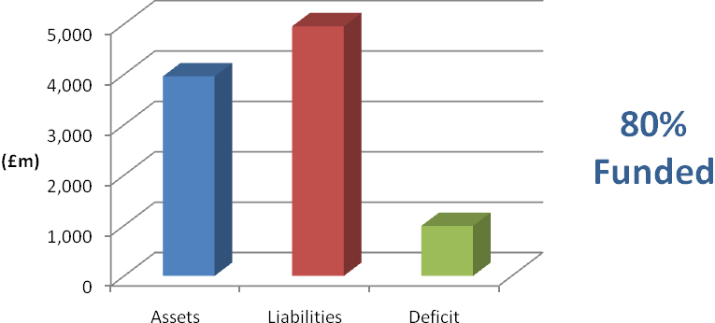

The valuation also showed that a common rate of contribution of 12.5% of pensionable pay per annum was required from employers. The common rate is calculated as being sufficient, together with contributions paid by members, to meet all liabilities arising in respect of service after the valuation date.
Adopting the same method and assumptions as used for assessing the Funding Target the deficit would be eliminated by an average additional contribution rate of 6.6% of pensionable pay for 19 years. This would imply an average employer contribution rate of 19.1% of pensionable pay in total.
Further details regarding the results of the valuation are contained in our formal report on the actuarial valuation dated 31 March 2011.

In practice, each individual employer’s position is assessed separately and the contributions required are set out in our report. In addition to the certified contribution rates, payments to cover additional liabilities arising from early retirements (other than ill-health retirements) will be made to the Fund by the employers (although certain employers have some allowance for non-ill health early retirement costs included in their certified contribution rate).
The funding plan adopted in assessing the contributions for each individual employer is in accordance with the Funding Strategy Statement (FSS) Funding Strategy Statement Different approaches adopted in implementing contribution increases and deficit recovery periods are as determined through the FSS consultation process.
The valuation was carried out using the projected unit actuarial method and the main actuarial assumptions used for assessing the Funding Target and the common contribution rate were as follows:

 | For past service liabilities (Funding Target) | For future service liabilities (Common Contribution Rate)
Rate of return on investments (discount rate)  - pre retirement  - post retirement | 7.0% per annum  5.5% per annum | 6.75% per annum  6.75% per annum
Rate of pay increases | 5.0% per annum | 5.0% per annum
Rate of increases in pensions  in payment (in excess of  Guaranteed Minimum Pension) | 3.0% per annum | 3.0% per annum

The assets were assessed at market value.
The next triennial actuarial valuation of the Fund is due as at 31 March 2013. Based on the results of this valuation, the contribution rates payable by the individual employers will be revised with effect from 1 April 2014.

- Actuarial Present Value of Promised Retirement Benefits

IAS 26 requires the present value of the Fund’s promised retirement benefits to be disclosed, and for this purpose the actuarial assumptions and methodology used should be based on IAS 19 rather than the assumptions and methodology used for funding purposes.

To assess the value of the benefits on this basis, we have used the following financial assumptions as at 31 March 2013 (the 31 March 2012 assumptions are included for comparison):

 |  | 31 March 2012 | 31 March 2013
 | Rate of return on investments (discount rate) | 4.9% per annum | 4.2% per annum
 | Rate of pay increases | 4.5% per annum | 4.4% per annum
 | Rate of increases in pensions  in payment (in excess of  Guaranteed Minimum Pension) | 2.5% per annum | 2.4% per annum

The demographic assumptions are the same as those used for funding purposes other than
the allowance for future improvements in life expectancy, which has been updated taking into account the latest evidence on this issue. The updated allowance underlying the 31 March 2013 calculations is in line with the projections model published in November 2009 by the Continuous Mortality Investigation (CMI) with a long-term improvement rate of 1.25% p.a. The previous allowance as at 31 March 2012 used a long-term improvement rate of 1.0% p.a.

During the year, corporate bond yields reduced, resulting in a lower discount rate being used for IAS26 purposes at the year end than at the beginning of the year (4.2% p.a. versus 4.9% p.a.). The impact of this was offset slightly by the 0.1% p.a. fall in assumed inflation.

The value of the Fund’s promised retirement benefits for the purposes of IAS26 as at 31 March 2012 was estimated as £6,254 million. The effect of the changes in actuarial assumptions between 31 March 2012 and 31 March 2013 as described above is to increase the liabilities by c£814 million. Adding interest over the year increases the liabilities by a further c£306 million, and allowing for net benefits accrued/paid over the period decreases the liabilities by c£1 million. The net effect of all the above is that the estimated total value of the Fund’s promised retirement benefits as at 31 March 2013 is therefore £7,373 million.

The policy for funding the promised retirement benefits is set out in the Funding Strategy Statement, the long term funding objective being for the Fund to achieve and maintain sufficient assets to cover 100% of projected accrued liabilities.

- Actuarial Valuation
An actuarial valuation of the Fund is carried out every three years by the Fund’s actuary Mercer. The most recent valuation carried out was at 31 March 2010 which determines contribution rates effective from 1 April 2011 to 31 March 2014.
The Funding objective is to achieve and then maintain assets equal to the Funding Target. The Funding Target is the present value of 100% of projective accrued liabilities, including allowance for projected final pay. This is to comply with the requirements of the LGPS regulations to secure the solvency of the Fund and is in accordance with the Funding Strategy Statement. The methodology and assumptions by which the Funding Targets and contribution rates are calculated have also been determined in accordance with the Funding Strategy Statement.
The Funding Strategy Statement specifies a maximum period for achieving full funding of 19 years, this compares to a maximum period of 22 years adopted at the 2007 valuation in accordance with the then published FSS. The maximum deficit recovery period is now three years shorter so that the same target date for achieving full funding is being maintained as at the 2007 valuation. The FSS also specifies any transitional arrangements ("phasing") for the implementation of revised employer contribution requirements.
The valuation (effective from 1 April 2011) revealed a funding level of 80% and an average employer’s contribution rate of 19.1%. There have been a number of material developments which have impacted on the fund since the previous valuation in 2007. The introduction of an Inflation Risk Premium (IRP) into the determination of the pension increase assumption used for the valuation has offset the adverse impact of the fall in real yields since the 2007 valuation. The effect of the IRP in conjunction with the change from RPI to CPI indexation more than offsets the negative impact of the yields change. Revisions of the assumptions adopted for the 2010 valuation has overall acted to place a lower value on liabilities and has therefore improved the funding position.
An extract from the certified Actuarial Valuation produced by Mercer as at 31 March 2010, detailing the breakdown of the 80% funding level is as follows:

Funding results – Funding Target

The market value of the Fund’s assets at the valuation date is compared with the value of the Fund’s past service liabilities (the Funding Target) below. The funding position at the previous valuation is shown for comparison. 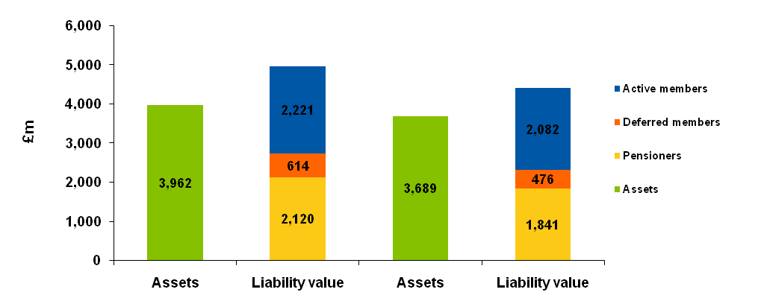
80%

84%

Total
£4,955m
Total
£4,399m
31 March 2010
31 March 2007

The employer contributions for 2011/2012 are based on the 2010 valuation and the recommended employer contributions for the period 1 April 2011 to 31 March 2014 are set out in the Schedule to the Rates and Adjustments at page 59 of this report.
The projected unit method of valuation was used for the valuation and is in common use for funding Pension Funds in the United Kingdom. The Valuation results depend on financial and demographic assumptions and these are detailed in full in the Actuarial Valuation and at Annex 1 of the Funding Strategy Statement.

The Rates and adjustments certified and accompanying schedule extracted from the actuarial valuation are as follows:

Rates and Adjustments Certificate issued in accordance with Regulation 36 of the Administration Regulations
Name of Fund | Lancashire County Pension Fund

I hereby certify that, in my opinion, the common rate of employers’ contributions payable in each year of the period of three years beginning 1 April 2011 should be at the rate of 12.5 per cent of Pensionable Pay.
I hereby certify that, in my opinion, the amount of the employers’ contributions payable in each year of the period of three years beginning with 1 April 2011, as set out above, should be individually adjusted as set out in the attached schedule.
Contributions will be payable monthly in arrears with each payment normally being due by the 19th of the following month. Pensionable Pay is pay as determined under the LGPS regulations for the calculation of employee contributions.
For employers where no allowance for non ill-health early retirement costs is included in the valuation a further individual adjustment shall be applied in respect of each non-ill health early retirement occurring in the period of three years covered by this certificate. This further individual adjustment will be calculated in accordance with methods agreed from time to time between the Fund’s actuary and the Administering Authority.
The contributions set out in the attached schedule represent the minimum contribution which may be paid by each employer. Additional contributions may be paid if requested by the employer concerned.
The contributions may be varied as agreed by the Actuary and Administering Authority to reflect any changes in contribution requirements as a result of any benefit costs being insured against a third party.
Regulation 36(8)
Allowance for ill health retirements has been included in each employer’s contribution rate, on the basis of the method and assumptions set out in the report.
For four employers I have shown on the attached Schedule the allowance made for non-ill health early retirements over the period of three years beginning 1 April 2011 taken into account when setting this employer’s contribution rate.
No allowance for non-ill health early retirements has been made in determining the results of the valuation for other employers, on the basis that the costs arising will be met by additional contributions.


Signature

Name John Livesey
Qualification Fellow of the Institute of Actuaries
Date of signing 31 March 2011

Schedule to the Rates and Adjustments Certificate dated 31 March 2011

 | 2011/12 |  |  | 2012/13 |  | 2013/14 |  | Non-ill health early retirement allowance included for the 3 years 2011/14
Employers | Individual Adjust-ment)  % | Total Contribu-tion Rate  % |  | Individual Adjust-ment  % | Total Contribu-tion Rate  % | Individual Adjust-ment  % | Total Contribu-tion Rate  % | Amount  £
ABM Catering Ltd | 3.5 | 16.0 |  | 3.5 | 16.0 | 3.5 | 16.0
Accrington & Rossendale College | 7.1 | 19.6 |  | 7.1 | 19.6 | 7.1 | 19.6
Accrington Academy | -1.8 | 10.7 |  | -1.8 | 10.7 | -1.8 | 10.7
Alternative Futures | 1.7 | 14.2 |  | 1.7 | 14.2 | 1.7 | 14.2
Andron (City of Preston High) | -1.2 | 11.3 |  | -1.2 | 11.3 | -1.2 | 11.3
Andron (Glenburn Sports College) | 0.5 | 13.0 |  | 0.5 | 13.0 | 0.5 | 13.0
Andron (Kennington) | 0.0 | 12.5 |  | 0.0 | 12.5 | 0.0 | 12.5
Andron (Ribblesdale High) | -0.3 | 12.2 |  | -0.3 | 12.2 | -0.3 | 12.2
Arnold Schools | 5.0 | 17.5 |  | 6.2 | 18.7 | 7.4 | 19.9
Beaufort Avenue Day Care Centre | 14.0 | 26.5 |  | 17.7 | 30.2 | 21.3 | 33.8
Blackburn College | 2.9 | 15.4 |  | 2.9 | 15.4 | 2.9 | 15.4
Blackburn St Mary's College | 1.7 | 14.2 |  | 1.7 | 14.2 | 1.7 | 14.2
Blackburn with Darwen Borough Council | 3.1 | 15.6 |  | 3.6 | 16.1 | 4.1 | 16.6
Blackpool & The Fylde College | 5.0 | 17.5 |  | 5.0 | 17.5 | 5.0 | 17.5 | £246,000
Blackpool Airport Ltd (from July 2004) | 20.5 | 33.0 |  | 24.5 | 37.0 | 27.8 | 40.3
Blackpool Borough Council | 3.9 | 16.4 |  | 4.4 | 16.9 | 4.9 | 17.4 | £697,600
Blackpool Coastal Housing | -0.5 | 12.0 |  | -0.5 | 12.0 | -0.5 | 12.0
Blackpool Sixth Form College | -0.5 | 12.0 |  | -0.5 | 12.0 | -0.5 | 12.0
Blackpool Transport Services Ltd | -12.5 | 0.0 |  | -12.5 | 0.0 | -12.5 | 0.0
Blackpool Zoo (Grant Leisure) | 5.5 | 18.0 |  | 7.1 | 19.6 | 8.8 | 21.3
Blackpool, Fylde & Wyre Society for the Blind | 29.5 | 42.0 |  | 32.5 | 45.0 | 35.5 | 48.0
Bootstrap Enterprise Ltd | 0.2 | 12.7 |  | 0.2 | 12.7 | 0.2 | 12.7
Bulloughs (Highfield) | -2.0 | 10.5 |  | -2.0 | 10.5 | -2.0 | 10.5
Bulloughs (St Augustines) | 1.9 | 14.4 |  | 1.9 | 14.4 | 1.9 | 14.4
Bulloughs (St Marys) | 4.0 | 16.5 |  | 4.0 | 16.5 | 4.0 | 16.5
 | 2011/12 |  |  | 2012/13 |  | 2013/14 |  | Non-ill health early retirement allowance included for the 3 years 2011/14
Employers | Individual Adjust-ment)  % |  | Total Contribu-tion Rate  % | Individual Adjust-ment  % | Total Contribu-tion Rate  % | Individual Adjust-ment  % | Total Contribu-tion Rate  % | Amount  £
Burnley Borough Council | 12.5 |  | 25.0 | 12.5 | 25.0 | 12.5 | 25.0
Burnley College | 2.3 |  | 14.8 | 2.3 | 14.8 | 2.3 | 14.8
Calico Housing Ltd | 6.8 |  | 19.3 | 6.8 | 19.3 | 6.8 | 19.3
CAPITA | 12.2 |  | 24.7 | 14.1 | 26.6 | 16.0 | 28.5
Capita (Rossendale BC) | 3.1 |  | 15.6 | 4.6 | 17.1 | 6.0 | 18.5
Cardinal Newman College | 3.3 |  | 15.8 | 3.3 | 15.8 | 3.3 | 15.8
Caritas Care Ltd (was Catholic Caring Services) | 6.2 |  | 18.7 | 6.2 | 18.7 | 6.2 | 18.7
Catterall Parish Council | 2.3 |  | 14.8 | 2.3 | 14.8 | 2.3 | 14.8
Chorley Borough Council | 6.8 |  | 19.3 | 7.3 | 19.8 | 7.8 | 20.3
Chorley Community Housing | 1.6 |  | 14.1 | 1.6 | 14.1 | 1.6 | 14.1
Church Road Methodist Day Centre | 6.7 |  | 19.2 | 7.0 | 19.5 | 7.3 | 19.8
Commission for Education & Formation | 8.0 |  | 20.5 | 8.0 | 20.5 | 8.0 | 20.5
Community Council of Lancashire | 8.3 |  | 20.8 | 8.3 | 20.8 | 8.3 | 20.8
Community Gateway Association Ltd | 1.7 |  | 14.2 | 2.4 | 14.9 | 3.0 | 15.5
Connaught Environmental (Blackpool BC) | -3.9 |  | 8.6 | -3.9 | 8.6 | -3.9 | 8.6
Connaught Environmental (Blackpool Coastal Housing) | 0.5 |  | 13.0 | 0.5 | 13.0 | 0.5 | 13.0
Consultant Caterers Ltd | 2.5 |  | 15.0 | 2.5 | 15.0 | 2.5 | 15.0
Contour Housing Association | 4.1 |  | 16.6 | 4.1 | 16.6 | 4.1 | 16.6
Creative Support Ltd | 1.6 |  | 14.1 | 1.6 | 14.1 | 1.6 | 14.1
CXL Ltd | -0.6 |  | 11.9 | -0.6 | 11.9 | -0.6 | 11.9
Danfo (UK) Ltd | 172.2 |  | 184.7 | 172.2 | 184.7 | 172.2 | 184.7
Darwen Aldridge Community Academy | -1.2 |  | 11.3 | -1.2 | 11.3 | -1.2 | 11.3
E ON UK Plc | 6.2 |  | 18.7 | 6.2 | 18.7 | 6.2 | 18.7
Edge Hill University College | 1.5 |  | 14.0 | 2.0 | 14.5 | 2.5 | 15.0
Enterprise Managed Services Ltd | 1.1 |  | 13.6 | 2.4 | 14.9 | 3.6 | 16.1
Eric Wright Commercial Ltd | 5.4 |  | 17.9 | 5.4 | 17.9 | 5.4 | 17.9
Fulwood Academy | -1.3 |  | 11.2 | -1.3 | 11.2 | -1.3 | 11.2
Fylde Borough Council | 7.0 |  | 19.5 | 8.3 | 20.8 | 9.5 | 22.0
Fylde Coast YMCA (Fylde) | -2.0 |  | 10.5 | -2.0 | 10.5 | -2.0 | 10.5

 | 2011/12 |  | 2012/13 |  | 2013/14 |  | Non-ill health early retirement allowance included for the 3 years 2011/14
Employers | Individual Adjust-ment)  % | Total Contribu-tion Rate  % | Individual Adjust-ment  % | Total Contribu-tion Rate  % | Individual Adjust-ment  % | Total Contribu-tion Rate  % | Amount  £
Fylde Community Link | 4.3 | 16.8 | 4.3 | 16.8 | 4.3 | 16.8
Galloways Society for the Blind | 32.2 | 44.7 | 32.2 | 44.7 | 32.2 | 44.7
Garstang Town Council | -1.3 | 11.2 | -1.3 | 11.2 | -1.3 | 11.2
Housing Pendle Ltd | 1.8 | 14.3 | 1.8 | 14.3 | 1.8 | 14.3
Hyndburn Borough Council | 12.3 | 24.8 | 12.3 | 24.8 | 12.3 | 24.8
Hyndburn Homes Ltd | 1.4 | 13.9 | 1.4 | 13.9 | 1.4 | 13.9
I Care | -1.6 | 10.9 | -1.6 | 10.9 | -1.6 | 10.9
Kirkham Grammar School | 4.1 | 16.6 | 4.6 | 17.1 | 5.1 | 17.6
Kirkland Parish Council | 2.5 | 15.0 | 2.5 | 15.0 | 2.5 | 15.0
Lancashire & Blackpool Tourist Board | 1.1 | 13.6 | 1.1 | 13.6 | 1.1 | 13.6
Lancashire County Branch Unison | 8.0 | 20.5 | 8.0 | 20.5 | 8.0 | 20.5
Lancashire County Council | 5.8 | 18.3 | 6.2 | 18.7 | 6.6 | 19.1
Lancashire Fire & Rescue Service | 5.0 | 17.5 | 5.0 | 17.5 | 5.0 | 17.5 | £199,000
Lancashire Police Authority | 2.3 | 14.8 | 2.8 | 15.3 | 3.3 | 15.8 | £450,500
Lancashire Probation Committee | 6.6 | 19.1 | 6.6 | 19.1 | 6.6 | 19.1
Lancaster & Morecambe College | 4.1 | 16.6 | 4.1 | 16.6 | 4.1 | 16.6
Lancaster City Council | 8.1 | 20.6 | 8.1 | 20.6 | 8.1 | 20.6
Lancaster University | 1.9 | 14.4 | 2.2 | 14.7 | 2.6 | 15.1
Leisure in Hyndburn | 3.3 | 15.8 | 4.5 | 17.0 | 5.7 | 18.2
Liberata | 6.0 | 18.5 | 6.0 | 18.5 | 6.0 | 18.5
Liberata UK Ltd (Chorley) | 8.9 | 21.4 | 8.9 | 21.4 | 8.9 | 21.4
Lytham Schools Foundation | 2.2 | 14.7 | 2.2 | 14.7 | 2.2 | 14.7
Mellor's (formerly Wyre) | 1.7 | 14.2 | 1.7 | 14.2 | 1.7 | 14.2
Mellor's Catering (Cardinal Newman) | 5.0 | 17.5 | 5.0 | 17.5 | 5.0 | 17.5
Myerscough College | 0.8 | 13.3 | 1.0 | 13.5 | 1.1 | 13.6
Nelson and Colne College | 3.3 | 15.8 | 3.3 | 15.8 | 3.3 | 15.8
New Fylde Housing | 42.3 | 54.8 | 42.3 | 54.8 | 42.3 | 54.8
New Progress Housing | 3.9 | 16.4 | 3.9 | 16.4 | 3.9 | 16.4

 | 2011/12 |  | 2012/13 |  | 2013/14 |  | Non-ill health early retirement allowance included for the 3 years 2011/14
Employers | Individual Adjust-ment)  % | Total Contribu-tion Rate  % | Individual Adjust-ment  % | Total Contribu-tion Rate  % | Individual Adjust-ment  % | Total Contribu-tion Rate  % | Amount  £
NHS PCT Blackburn | 1.6 | 14.1 | 1.6 | 14.1 | 1.6 | 14.1
NIC Services Group Ltd | 2.5 | 15.0 | 2.5 | 15.0 | 2.5 | 15.0
North Western & North Wales Sea Fisheries Committee | 13.4 | 25.9 | 13.4 | 25.9 | 13.4 | 25.9
Northgate Managed Services | 0.1 | 12.6 | 0.1 | 12.6 | 0.1 | 12.6
NSL Ltd (Lancaster) | 4.5 | 17.0 | 4.5 | 17.0 | 4.5 | 17.0
NSL Ltd (Wyre BC) | 0.6 | 13.1 | 0.6 | 13.1 | 0.6 | 13.1
Ormerod Home Trust Ltd | 11.7 | 24.2 | 13.7 | 26.2 | 15.5 | 28.0
Our Lady Queen of Peace (Bullough Contract Services) | 3.5 | 16.0 | 3.5 | 16.0 | 3.5 | 16.0
Pendle Borough Council | 12.1 | 24.6 | 14.1 | 26.6 | 16.2 | 28.7
Pendle Leisure Trust Ltd | 1.2 | 13.7 | 1.2 | 13.7 | 1.2 | 13.7
Penwortham Town Council | 1.5 | 14.0 | 1.5 | 14.0 | 1.5 | 14.0
Pilling Parish Council | 4.8 | 17.3 | 4.8 | 17.3 | 4.8 | 17.3
Preston Care and Repair | 6.0 | 18.5 | 6.0 | 18.5 | 6.0 | 18.5
Preston City Council | 5.6 | 18.1 | 6.1 | 18.6 | 6.6 | 19.1
Preston College | 2.7 | 15.2 | 3.0 | 15.5 | 3.3 | 15.8
Preston Council for Voluntary Services | 9.4 | 21.9 | 9.4 | 21.9 | 9.4 | 21.9
Progress Care Housing | 3.9 | 16.4 | 3.9 | 16.4 | 3.9 | 16.4
Progress Housing Group Ltd | 3.9 | 16.4 | 3.9 | 16.4 | 3.9 | 16.4
Progress Recruitments | 2.9 | 15.4 | 2.9 | 15.4 | 2.9 | 15.4
Queen Elizabeth's Grammar School | 8.3 | 20.8 | 9.3 | 21.8 | 10.3 | 22.8
Ribble Valley Borough Council | 3.6 | 16.1 | 4.1 | 16.6 | 4.6 | 17.1
Ribble Valley Homes | 1.8 | 14.3 | 1.8 | 14.3 | 1.8 | 14.3
Rossendale Borough Council | 13.8 | 26.3 | 15.3 | 27.8 | 16.8 | 29.3
Rossendale Leisure Trust | 0.2 | 12.7 | 1.2 | 13.7 | 2.1 | 14.6
Rossendale Transport Ltd | 10.7 | 23.2 | 19.3 | 31.8 | 27.8 | 40.3
Runshaw College | 2.6 | 15.1 | 2.9 | 15.4 | 3.2 | 15.7
Signposts MARC Ltd | -12.5 | 0.0 | -12.5 | 0.0 | -12.5 | 0.0

 | 2011/12 |  | 2012/13 |  | 2013/14 |  | Non-ill health early retirement allowance included for the 3 years 2011/14
Employers | Individual Adjust-ment)  % | Total Contribu-tion Rate  % | Individual Adjust-ment  % | Total Contribu-tion Rate  % | Individual Adjust-ment  % | Total Contribu-tion Rate  % | Amount  £
Solar Facilities (Bishop Raws) | -12.5 | 0.0 | -12.5 | 0.0 | -12.5 | 0.0
Solar Facilities (Ripley) | 8.5 | 21.0 | 8.5 | 21.0 | 8.5 | 21.0
Solar Facilities (Seven Stars) | 3.4 | 15.9 | 3.4 | 15.9 | 3.4 | 15.9
Solar Facilities (St Peters) | -3.0 | 9.5 | -3.0 | 9.5 | -3.0 | 9.5
Solar Facilities (Tarelton) | 1.4 | 13.9 | 1.4 | 13.9 | 1.4 | 13.9
South Ribble Borough Council | 6.8 | 19.3 | 7.8 | 20.3 | 8.8 | 21.3
South Ribble Community Leisure Ltd | 10.4 | 22.9 | 10.4 | 22.9 | 10.4 | 22.9
St Anne's on Sea Town Council | -1.4 | 11.1 | -1.4 | 11.1 | -1.4 | 11.1
Surestart Hyndburn | -2.0 | 10.5 | -1.0 | 11.5 | -0.1 | 12.4
Twin Valley Homes Ltd | 3.8 | 16.3 | 3.8 | 16.3 | 3.8 | 16.3
University of Central Lancashire | 1.6 | 14.1 | 1.6 | 14.1 | 1.6 | 14.1
University of Cumbria (was St Martins College) | 1.5 | 14.0 | 1.5 | 14.0 | 1.5 | 14.0
Vita Lend Lease BSF ICT | 0.2 | 12.7 | 0.2 | 12.7 | 0.2 | 12.7
Vita Lend Lease Ltd | 1.3 | 13.8 | 1.3 | 13.8 | 1.3 | 13.8
West Lancashire Borough Council | 7.5 | 20.0 | 7.5 | 20.0 | 7.5 | 20.0
West Lancashire Community Leisure Ltd | -0.5 | 12.0 | -0.5 | 12.0 | -0.5 | 12.0
Whitworth Town Council | 3.6 | 16.1 | 3.6 | 16.1 | 3.6 | 16.1
Wyre Borough Council | 12.6 | 25.1 | 12.6 | 25.1 | 12.6 | 25.1
Wyre Housing Association | 57.8 | 70.3 | 57.8 | 70.3 | 57.8 | 70.3
Other interested bodies with no pensionable employees

Former Employers | Proportion of Pension Increases to be Recharged  % |  | Former Employers | Proportion of Pension Increases to be Recharged  %
Alzheimer's Society | See notes |  | Ex Department of Transport | 100
Barnoldswick Town Council | See notes |  | Ex National Health Service | 100
Blackpool & Fylde Mind Association | See notes |  | Ex National Water Council | 100
Blackpool & Fylde Society for the Deaf | 100 |  | Fylde Coast Development Association | 100
Blackpool Town Centre Forum Ltd | See notes |  | Lancashire South East Probation Committee | 100
Bulloughs (St Albans) | See notes |  | Lancashire Valuation Tribunal | See notes
Burnley & Pendle Development Association | 100 |  | New Directions | See notes
Burton Manor Residential College | 100 |  | Preston Vision Ltd | See notes
Carden Croft Ltd | See notes |  | Salmesbury & Cuerdale Parish Council | See notes
Community Alliance (Burnley & Padiham) Ltd | See notes |  | Skelmersdale College | See notes
CSB Contract Services | See notes |  | Spastics Society | 100
Elm House Management Committee | See notes

Note:
Members of the Fund employed by Skelmersdale College have transferred to membership of the Tyne and Wear Fund, and so a bulk transfer payment will be required. Any residual funding shortfall in the LCPF after the transfer payment should then be recovered from the College.

For the remaining employers listed as "see notes" above further calculations are required in connection with them ceasing to participate in the Fund. Further details for these employers will be notified in due course.

- Contacts

http://www.yourpensionservice.org.uk

Benefits and other Administrative Issues

Pensions Helpdesk
Your Pension Service
PO Box 100
County Hall
Preston
PR1 0LD
Telephone: 01772 530530
E-mail: connect2pensions@oneconnectlimited.co.uk

Pension Benefits and Administration

Diane Lister
Head of Your Pension Service
Telephone: 01772 534827
E-mail: connect2pensions@oneconnectlimited.co.uk

Pension Fund Accounts

Abigail Leech
Head of Financial Accounting & Taxation
Telephone: 01772 530808
E-mail: abigail.leech@lancashire.gov.uk

Pension Fund Investments

Mike Jensen
Chief Investment Officer
Telephone: 01772 534742
E-mail: mike.jensen@lancashire.gov.uk

Pension Fund Governance

Andrew Fox
Head of Investment Compliance
Telephone: 01772 53535916
E-mail: andrew.fox@lancashire.gov.uk

